Electronics World: Store Management

Computer Science 342: Database Systems
Team members: Jennifer Montenegro, Joshua Cornelison
and Kevin Lee

Table of Contents

Phase 1
1.1 Fact Finding Techniques….………………………………………………………………………….4
1.2 Conceptual Database Design…….………………………………………………………………..6
1.3 Relationship Set Description……..………….……..……………..……………………………12
1.4 E-R Diagram………………..…………………………………………………………………………….16
Phase 2
2.1 E-R (conceptual)model to Relational(logical)model……….………………………….17
2.2 E-R Database to Relational Database…………….……….………………………………….20
2.3 Relational Instances………….………….……………………………………………………………27
2.4 Employee……………….………………….………………………………………………………………27
2.5 Sale Relation………………..…………………………………………………………………………….28
2.6 Store Relation……………..………………………………………………………………………….....29
2.7 Distributors relation……………………..…………………………………………………………....30
2.8 Order relation………………………..……………………………………………………………………31
2.9 Electronics………………………..…………………………………………………………………………32
2.10 Inventory History relation………………………………………………………………………….33
2.11 Orders placed..………………………………………………………………………………………….34
2.12Works for/manages……………………………………………………………………………………35
2.13 Queries…………..…………………………………………………………………………………………36
2.14 Representation of Queries…………………………………………………………………………37
Phase 3
3.1 Normalization of Relations…………………………………………………………………………41
3.2 Oracle/SQLPLUS Queries…..….…………………………………….……………………………..44
3.3 Normalization of Relations…….………………….……………………………………………….50
3.4 SQLPLUS…………….…………………….……………………………………………………………..…53
3.5 Schema Objects……..………………….……………………………………………………………….54
3.6 Relational Schema and Content...……………………………………………………………….57
3.7 SQL Queries………………………………………………………………………………………………..67
3.8 Data Loader….…………………………...……………………………………………………………….73
Phase 4
4.1 Oracle PL/SQL General Description……………………………………………………….……..74
4.2 Report…..……………………………………………………………………………………………………..74
4.2.1 Common Features in Oracle PL/SQL and MS Trans-SQL.………….………………..74
4.2.2 Oracle PL/SQL……….……………………………..………………………………………..………….75
4.2.3 Oracle PL/SQL Subrogram………………………………………………………………………….77
Phase 5
5.1 General Description………………………………………………………………………………………79
5.2 Stored Procedures………………………………………………………………………………………..80
5.3 Description of daily activities of user groups…………………………………………………81
5.4 Design interface……………………………………………………………………………………………82
5.5 Major Classes……….……………………………………………………………………………………...83
  - Screenshots…………………………………………………………………………………………………..85
  - Major steps in designing and implementing database application…………..…….88
  - Major features of the GUI……………………………………………………………………………..89
5.9 Learning a new development tool and writing code in a new language............90

Fact-Finding, Information Gathering and Conceptual Database Design

1.1 Fact Finding Techniques
We went to newegg.com. We saw how the website was organized to make our organization of departments similar. We checked out how all the different sections were set up on the site. For example computer was broken up into desktops and laptops. Then laptops are broken up into laptops and netbooks.
Other stores that were not dedicated to electronics, but had an electronics department were Walmart and Office Depot. Walmart has everything that we want to sell so it was a good store to look at. We saw that everything was separated within the department like TVs and computers. For Office Depot they had a computer department that had desktops, notebooks, netbooks.
We also went to best buy to see how that store was set up. They were sectioned off into different departments; however, we will be having two different stores with no separate departments for now. Since the stores are small we will not be having different departments. We might designate different employees to sell something different but not necessarily have different departments.
Introduction of Enterprise/Organization:
Our business is going to selling computers: desktop, netbook, laptops; video games consoles: ps3, xbox, wii; games: pc games, console games; hardware: accessories and parts; cameras: video cameras, still picture cameras; TVs; ipods.
We are a small chain that is selling electronics and computers. Thinking about possibly including: fixing and installing computer hardware and software.
Structure of Enterprise:
Our database is going to be keeping track of inventory that is coming in from different vendors and being sold. We are going to be keeping track of the sales and profit/loss. We are also keeping track of the employee start time/end times from when the start working for the store and when stop. We are also keeping track of their pay checks. For the employees we have, we also check to see if the employee is a supervisor. At most we will have two supervisors, one for each store. Our database will also keep track of orders and if they are being filled and by which distributors. The main entity sets include the table for Employees, sales, orders, vendors, and inventory history.

Itemized descriptions of Entity sets and relationship sets:
An employee entity is basically and employee working for our stores. Our store entity will have the name of our store and have the supervisors. The orders entity keeps track of the items being ordered and the vendors distributing them. The vendor entity keeps track of the names and contact information. The sales entity will keep track of the store number and quantities and specific electronics sold.
The history inventory entity keeps track of the inventory being sold and what we have in stock. It was also be keeping track of the history of sales, such as the sales for last month. It will also be keeping track of profit of loss that the company has.

User Groups, Data views and Operations:
User groups will employees.
Employees will be able to input their time so will be using the reporting operation. We are still debating whether or not to let employees check to see if a product a customer is looking for is in stock or keep that for a supervisor.
Supervisors will be a field under supervisor that will allow checking inventory, placing orders(using the add operation), making sure orders were filled. Supervisors can also remove employees if they quit or are fired for any reason. The supervisor will be able to assign which employee works for which department. The supervisor can also check the stock available for a customer. A supervisor can also view the sales and the items that were sold to maybe keep track of each of the departments. A supervisor can also remove or change and orders that are placed wrong.

1.2 Conceptual Database Design

Employee
- This entity holds all of the information related to the employee. It contains their id, first name, last name, and their address.
- Candidate keys: Fname, Lname
- Primary key: Eid
- Strong/weak entity: strong
- Fields to be indexed: Eid, Fname, Lname
- Attributes:
Name | Eid | Fname | Lname | Address
Description | Employee id number | Employee first name | Employee last name | Employee address
Domain/Type | Unsigned integer | String | String | String
Value Range | 0…2^32 | Any | Any | Any
Default Value | None | None | None | None
Nullable? | No | No | No | No
Unique? | Yes | Yes | Yes | Yes
Single or multiple value | Single | Single | Single | Single
Simple or composite | Simple | Composite | Composite | Simple

Sales
- This entity type describes the sales made at our store. It also keeps track at which store made the sales and when they were made.
- Candidate key: Date,STid
- primary key: Sid
- strong/Weak Entity: strong
- fields to be indexed:Sid, Stid
- Attributes:
Name | Sid | Date | STid
Description | Sale id number on the receipt | The date sales were done | The store id number
Domain/Type | Unsigned integer | Date | Unsigned inter
Value Range | 0…2^32 | None | 0...2^32
Default Value | None | None | None
Nullable? | No | No | No
Unique? | Yes | Yes | Yes
Single or multiple value | Single | Single | Single
Simple or composite | Simple | Simple | Simple

Store
- this entity describes the stores we have. We have 2 stores. The stores location will also be kept so we know which stores make what sales and who is currently working at that store.
- Candidate keys: Storename,location
- primary key: Stid
- strong/weak entity: weak
- fields to be indexed: stid, storename, location
- attributes:
Name | Stid | Storename | Number | Location
description | The store's id number | Name of the store | The number of the stores | Where the store is located
Domain/type | Unsigned integer | String | Integer | String
Value range | 0...2^32 | Any | 1000000-9999999 | Any
Default value | None | None | None | None
Nullable? | No | Yes | Yes | Yes
Unique? | Yes | No | Yes | Yes
Single or multiple value | single | Multiple | Single | Single
Simple or composite | Simple | Composite | Simple | Composite

Distributor
- this entity describes the distributor where we buy our supplies from. This contains their name, location and the number we use to contact them.
- Candidate key: Cname,Address
- primary key: Disid
- strong/weak entity: weak
- fields to be indexed: disid, cname, address
- attributes
Name | Disid | Cname | Address | Phone number
description | The distributor id number | The companies name | The address of the company | The company phone number
Domain/type | Unsigned integer | String | String | Integer
Value range | 0..2^32 | Any | Any | 1000000-9999999
Default value | None | No | No | None
Nullable? | No | No | No | Yes
Unique? | Yes | No | Yes | Yes
Single or multiple value | single | Multiple | Single | Single
Simple or composite | simple | Composite | composite | Simple

Orders
- This entity will keep track of our orders. This will keep track of the time date and the items we have order.
- Candidate keys: Cname,Items
- primary key: Oid
- strong/weak entity: strong
- fields to be indexed: oid, cname,items
- attributes
Name | Oid | Items | Date | Cname
description | The order id number | The items ordered | The date they items were ordered. | The company name
Domain/type | Unsigned integer | String | Date | String
Value range | 0..2^32 | Any | Date | Any
Default value | None | None | No | No
Nullable? | No | No | No | No
Unique? | Yes | Yes | Yes | No
Single or multiple value | single | Single | Single | Multiple
Simple or composite | simple | Simple | Simple | Simple

Inventory History
- This entity keeps track of our profits and inventory every month. It will show how much we made or loss for the month. It will also show how much inventory we have.
- Candidate keys: amountSold,Profit/loss
- primary keys: oid,partid
- strong/weak entity: weak
- fields to be indexed: oid, partid, amountsold, profit/loss
- attributes
Name | Oid | Partid | AmountSold | Profit/loss | Eom qty
description | The order id number | The part id number | How many of an item we sold | How profit after a month | End of the month quantities
domain/type | Unsigned integer | Unsigned integer | Integer | float | Integer
Value range | 0..2^32 | 0..2^32 | 0..2^32 | -99999.0-99999.0 | 0..2^32
Default value | none | None | None | none | None
Nullable? | No | No | No | no | No
Unique? | Yes | Yes | No | yes | Yes
Single or multiple value | single | Single | Multiple | single | Single
Simple or composite | composite | Composite | Simple | simple | Simple

1.3 Relationship Set Description
'Works For'
Description:
This describes the relation between the 'Employee' class and the 'Store’ class. The relation is there to be to keep track of which employees work at which store. We also have a supervisor inside the employee. At the moment the business plan is to only have one supervisor work at one store. The relationship will include the Employee ID and the Store ID and each store will have multiple Employees.

Entity Sets Involved:
'Employee' and 'Store'.

Mapping Cardinality:
One -to- Many. One store can have many employees.

Participation Constraint:
optional/mandatory?: Mandatory.

'Generates'
Description:
This relation is between the 'Employee' class and the 'Sales' class. This relation is to track which employee is making which sale. We will be keeping track of the Employee ID and the Sales ID so we have documentation on who is selling products better.

Entity Sets Involved:
'Employee' and 'Sales'

Mapping Cardinality:
This will be a 1-to-1 relationship.

Participation:
optional/mandatory?: mandatory

'Contains'
Description:
This relationship involves the 'Sales' class and the 'Electronics' class. It is to see what the consumer has bought, such as amount, price, when, ect. The Sales ID and the Part ID will be what us stored into the relation.

Entity Sets Involved:
'Sales' and 'Electronics'

Mapping Cardinality:
1-to-Many relationship. Each sale can have multiple electronics.

Participation:
optional/mandatory?: Mandatory. There must be a relation between what is being sold.

'Places'
Description:
This relationship set is between the 'Employee' class and the 'Orders' class. This 'Orders' class has basically two tiers, the order and the distributor, but for this relationship the supervisor is making an order(s) to replenish his/her stock for the store. The Supervisor fills out an order form that contains which supervisor is making the order and what the order consists of, for instance, how many parts from which vender.

Entity Set Involved:
'Employee', 'Orders', and 'Vender'

Mapping Cardinality:
Many-to-Many

Participation Constraint:
optional/mandatory?: optional

‘Keeps Track’
Description:
This relationship keeps track of our inventory for the month. This relation is for the two Class’s, Electronics and Inventory history. This will also be keeping track of profits and losses for the store.

Entity Set Involved:
Electronics and Inventory History.

Mapping Cardinality:
Many-to-One

Participation Constraint:
Optional/Mandatory?: mandatory

Related Entity Set:
Currently we do not have any specialization. All the classes are generalized and do not have a subclass. Depending on the data we do decide to enter, we may make employees into a subclass and have a specialization. There are no participation constraints nor disjoint constraints within our diagram of our design at the moment because we do not have subclasses. We do not have any aggregation within out database design at the moment.
1.4 E-R Diagram
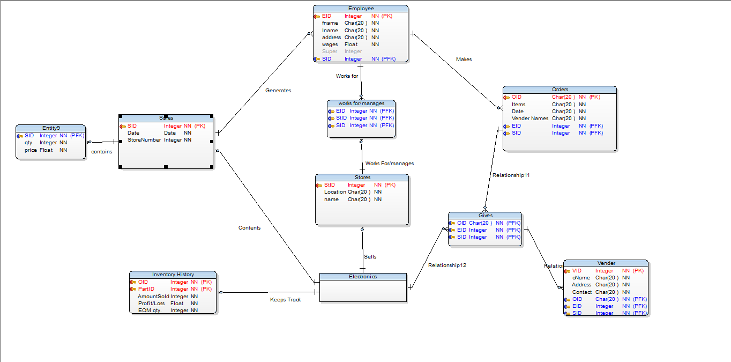
Phase II: From ER (Conceptual) Model to Relational (Logical) Model

2.1 ER model and relational model________________
Description of E-R Model and Relational Model
The Entity Relationship model was developed in 1976 by Peter Chen because he felt that the relational model was not sufficient enough. It is used for a conceptual design of a database application. The ER model includes use of attributes, entities (objects), tuples, and relationships. It is used to get information about the objects and shows the relationships between objects. Relationship sets are organized by corresponding entities.
The Relation Model was invented by EF Codd as a general model of data. All the data is represented by mathematical relations. For each of the relations data reasoning, there is predicate logic showing that there are only two values: true or false. The relational model requires a data type, tuples, sets, and attributes. A relation has a heading and a body.
Comparison of the two different models
The E-R model can tell the difference between different objects described by the attributes and relationships. It also provides an illustrated picture of what the database format may look like. The E-R model also has specialization and generalization to specify super classes and subclasses.
Everything in a relational model is a mathematical relation concerning domains. The relational model shows similar information to the E-R model, however it is in a table. Each table is a relation and each row in the table is a valid record (tuple). It allows for a description of the data and information in the table. The relational model is closer to what the actual database looks like because it also has tables. The relational model has constraints on the domains of the relation sets.
Conversion from the E-R model to Relational Model
First a conceptual model is needed for a relational model. The conceptual model is the entity- relationship model. However, you need to have an E-R model with union types, generalizations, and specializations. For strong entity type in an E-R model, there needs to be a relation that is created. The attributes that were in the E-R model will be included in the relation. Each relation is represented as a table and each attribute will be a column on that table. One of the attributes in the E-R model is chosen to be the primary key for the relation. Any other attributes can be chosen for a composite key.
Since weak entity sets cannot exist alone their attributes need to be mapped to their relation. A table needs to be created for each weak entity set and each column for has an attribute in the weak entity set. The table needs to have an extra column for a primary key of the strong entity set that it depends on.
Next is the representation of the relationship sets.
- For a 1-to-1 relationship
(with one entity set having total participation)
  - Add another column on the right side of the table of the entity set with total participation. This is for the primary key of the entity set without complete participation to the relationship.
(without total participation )
  - Build a table with two columns, one column for each participating entity set’s primary key. If you have a descriptive attribute, then successive columns are added, one for each descriptive attributes of the relationship set.

- For one-to-many relationship
(with one entity set having total participation)
  - Add another column on the right side of the table of the entity set on the many side, put in there the primary key of the entity set on the one side as per to the relationship.
( without total participation )
  - Build a table with two columns, one column for each participating entity set’s primary key. If you have a descriptive attribute, then successive columns are added, one for each descriptive attributes of the relationship set.
- For many-to-one relationship
(with one entity set having total participation)
  - This is the same as one to many, but opposite direction. Add another column on the right side of the table of the entity set on the many side, put in there the primary key of the entity set on the one side as per to the relationship.
( without total participation )
  - Build a table with two columns, one column for each participating entity set’s primary key. If you have a descriptive attribute, then successive columns are added, one for each descriptive attributes of the relationship set.

- For many-to-many relationship
  - Same as one-to-one relationship without total participation. The primary is the union of the foreign keys of both entity sets. There is no adding a column here.
Super classes and Subclasses Relationships
For generalization there are super classes. For specializations, there are subclasses. For each super class you create one relation, no matter how many attributes it has. Then you need to create a relation for each subclass. Next the attributes for the super class are joined with the attributes of the subclasses. Then a key is chosen to specify the primary key for the sublass.
You can also create one relation for all the super classes and subclasses. Their attributes would be unioned, however it can cause many NULL entries in the tuples.
Relationships with one entity type and two or more entity types
A recursive relation has only one entity type. You need to create one relation that has every attribute of all the specializations. It also has a description field that specializes in giving the entity which the attribute belongs to. This works for only disjoint specializations.
For a relation with two entity types, only one relation needs to be created. This relation needs to have all the attributes of all the specializations. The relation also requires a field for each specialization to specify which entity belongs to that specialization. This works for disjoint, total, partial, and overlapping specializations.
Constraints
A databases management system enforces different constraints on a several relations. The entity constraint makes sure that no primary key in a relation can be NULL, therefore making individual tuples in a relation to be identified uniquely. They need to be unique for identifying the elements tuple to be uniquely identifiable for comparisons and representations in queries. Primary key constraints eliminate primary keys and unique keys from being duplicated in a relation; unique keys do this as well. Referential constraints do not allow a tuple to be deleted if it is being referenced by another entity. Check constraints and business rules are unique to serve a specific business itself and a particular database; they are usually implemented in a client interface.

2.2 E-R Database to Relational Database
Employee Relation
Attributes
- EID
  - Domain: unsigned integer: 0…2^32. Cannot be NULL.
- Fname
  - Domain: String. Only holds first name. Cannot be NULL.
- Lname
  - Domain: String. Only holds last name. Cannot be NULL.
- Address
  - Domain: String. Holds the address of the employee. Cannot be NULL.
- Super
  - Domain: Integer. Holds a 1 or a 0. Cannot be NULL
Constraints
- Primary Key: EmployeeID: Primary key for the Employee relation. This must be a unique number and cannot be NULL.
- Business Rule: There can only be 1 supervisor per store. Supervisor is denoted with a 1 in the “Super” column.
Candidate Key
- Fname
- Lname

Sales Relation
Attributes
- SID
  - Domain: unsigned integer. 0…2^32. Unique. Cannot be NULL.
- Date
  - Domain: Date. Cannot be NULL.
- STid
  - Domain: Unsigned integer. 0...2^32. Cannot be NULL
Constraints
- Primary Key: SID. Primary key for the Sales Relation.
- Business Rule: There must be a STid for every SID.

Candidate Key
- Date
- STid

Store Relation
Attributes
- STid
  - Domain: unsigned integer. 0…2^32. Unique. Cannot be NULL.
- StoreName
  - Domain: String. Cannot Exceed 128 characters. Cannot be NULL.
- Location
  - Domain: String. Cannot Exceed 128 characters. Cannot be NULL.
Constraints
- Primary Key: STid.
Candidate Key
- StoreName
- Location

Distributor Relation
Attributes
- DisID
  - Domain: Unsigned Integer. 0…2^32. Cannot be NULL.
- Cname
  - Domain: String. 128 characters. Cannot be NULL.
- Address
  - Domain: String. 128 characters. Cannot be NULL.
- PhoneNumber
  - Domain: Number. 20 numbers. Cannot be NULL.

Constraints
- Primary Key: DisID
- Foreign Key: OID, EID, SID

Candidate Key
- Cname
- Address

Orders Relation
Attributes
- Oid
  - Domain: Unsigned integer. 0…2^32. Cannot be NULL.
- Items
  - Domain: String. 128 characters. Default vaule – None. Cannot be NULL.
- Date
  - Domain: Date. Cannot be NULL.
- Cname
  - Domain: String. 128 characters. Cannot be NULL.
- EID
  - Domain: unsigned integer: 0…2^32. Cannot be NULL.
- DisID
  - Domain: unsigned integer. 0…2^32. Unique. Cannot be NULL.
Constraints
- Primary Key: OID
- Foreign Key: EID, SID

Candidate Key
- Cname
- Items
- EID
- DisID

Electronics
Attributes
- PartID
  - Domain: Unsigned Integer: 0…2^32. Cannot be NULL.
- Pname
  - Domain: String. 50 characters. Cannot be NULL.
- Price
  - Domain: Float. -99999.0 – 99999.0. Cannot be NULL.
- OID
  - Domain: Unsigned Integer. 0…2^32. Cannot be NULL.
- Description
  - Domain: String. 128 characters. Can be NULL.
Constraints
- Primary Key: PartID
Candidate Key
- Pname

Inventory History Relation
Attributes
- OID
  - Domain: Unsigned Integer. 0…2^32. Cannot be NULL.
- PartID
  - Domain: Unsigned Integer. 0…2^32. Cannot be NULL.
- AmountSold
  - Domain: Integer. 0…2^32. Cannot be NULL.
- Profit/Loss
  - Domain: Float. -99999.0 – 99999.0. Cannot be NULL.
- EOM_Qty
  - Domain: Integer. 0…2^32. Cannot be NULL.
Constraints
- Primary Key: OID, PartID
Candidate Key
- AmountSold
- Profit/Loss

Orders Place Relation
Attributes
- OID
  - Domain: Unsigned Integer. 0…2^32. Cannot be NULL.
- EID
  - Domain: unsigned integer: 0…2^32. Cannot be NULL.
- StID
  - Domain: unsigned integer. 0…2^32. Unique. Cannot be NULL.
Constraints
- Foreign Key: OID, EID, SID.
Candidate Key
- OID
- EID
- StID

WorksFor/Manages
Attributes
- EID
  - Domain: unsigned integer: 0…2^32. Cannot be NULL.
- StID
  - Domain: unsigned integer. 0…2^32. Unique. Cannot be NULL.
- SID
  - Domain: unsigned integer. 0…2^32. Unique. Cannot be NULL.
Constraints
- Foreign Key: EID, StID, SID.
Candidate Key
- EID
- StID
- SID

2.3 Relational Instances________________
Employee
Eid | Fname | Lname | Address | Wages | supervisor
1 | Darth | Vader | 1334 Death Star street | Salary | 1
2 | Luke | Skywalker | 1442 Hoth street | Salary | 0
3 | Jack | Daniels | 1778 Whiskey street | Hourly | 0
4 | Dante | Sparta | 1003 Devil court | Salary | 1
5 | Vergil | Sparta | 1004 Devil court | Hourly | 0
6 | Kenshin | Himura | 3446 Japan street | Hourly | 0
7 | Captain | Morgan | 8775 Rum street | Salary | 0
8 | Ryu | Hayabusa | 6783 Ninja street | Salary | 1
9 | Samus | Aran | 1024 Metroid road | Hourly | 0
10 | Diddy | Kong | 7894 Banana road | Hourly | 0

Sales Relation
Sid | Date | stid
1 | 10/20/09 | 4
2 | 11/21/09 | 4
3 | 08/02/09 | 5
4 | 07/04/09 | 6
5 | 08/11/09 | 8
6 | 01/12/09 | 9
7 | 01/12/09 | 1
8 | 06/05/09 | 1
9 | 08/11/09 | 2
10 | 09/12/09 | 1

Store relation
Stid | Store name | Location
1 | Electronics World | 1234 Oven street
2 | Electronics World | 7243 Namek street
3 | Computers R Us | 2301 Spatula road
4 | Electronics World | 0986 Mouse Court
5 | Electronics World | 2456 Keyboard Street
6 | Electronics World | 0012 Halloween road
7 | Computers R Us | 9786 Shafter road
8 | Electronics World | 0916 Disney street
9 | Computers R Us | 2222 Fortress street
10 | Electronics World | 7563 Trash can road

Distributor relation
Disid | Cname | Address | Phone Number | Oid
1 | Kevin's Computer Parts | 1923 Fat street | 661-567-1344 | 5
2 | Jenny's Noob Factory | 6332 Sunglass street | 661-367-2345 | 5
3 | Asus | 8654 Pivot street | 661-689-2367 | 4
4 | Nivida | 4431 Chair Road | 567-175-2546 | 3
5 | Intel | 0987 Bridge street | 567-963-1248 | 3
6 | Zodiac | 8965 Printer Road | 661-023-5471 | 2
7 | Msi | Trash Can court | 661-876-2453 | 1
8 | AS Rock | 8944 Poster road | 897-224-6785 | 7
9 | Cannon | 0099 Paper street | 897-124-8544 | 9
10 | Dell | 1232 Joke street | 897-278-9754 | 7

Order Relation
Oid | Items | Date | Cname | Eid | Sid
1 | Ram | 08/02/09 | Msi | 2 | 8
2 | Ram | 10/20/09 | Msi | 5 | 7
3 | Motherboard | 11/21/09 | AS rock | 6 | 8
4 | Camera | 07/04/09 | Cannon | 4 | 6
5 | Camera | 08/11/09 | Cannon | 7 | 6
6 | Motherboard | 01/12/09 | Asus | 3 | 3
7 | Videocard | 01/12/09 | Nividia | 5 | 3
8 | Videocard | 01/12/09 | Zodiac | 6 | 2
9 | Monitor | 09/12/09 | Dell | 7 | 1
10 | Mouse | 09/12/09 | Kevin's Computer parts | 7 | 10

Electronics
Partid | Pname | Price | Oid | descriptions
1 | Mouse | $100.22 | 2 | 5400dpi
2 | Motherboard | $66.43 | 3 | Dual core
3 | Motherboard | $78.11 | 3 | Quad core
4 | Ram | $1,000.99 | 2 | 4gig reaper
5 | Ram | $788.54 | 1 | 4 gig gskill
6 | Motherboard | $82.12 | 6 | Processor holder
7 | Videocard | $803.12 | 8 | Gtx nivida gt 560
8 | Monitor | $56.99 | 9 | 42'lcd
9 | Videocard | $67.99 | 7 | Gtx ti nivida 9800
10 | Mouse | $45.36 | 10 | Razor mouse

Inventory history relation
Oid | Partid | AmountSold | Profit/loss | EOM_Qty
2 | 1 | 20 | 1000.21 | 0
3 | 2 | 12 | 897.33 | 8
3 | 3 | 1 | -133.56 | 19
2 | 4 | 1 | -9.54 | 19
1 | 5 | 6 | -561.12 | 14
6 | 6 | 7 | -12.45 | 13
8 | 7 | 9 | 89.21 | 11
9 | 8 | 0 | -90.65 | 20
7 | 9 | 0 | -81.12 | 20
10 | 10 | 12 | 900.32 | 10

Orders Place relation
Oid | Eid | sid
1 | 4 | 1
2 | 5 | 2
3 | 9 | 5
4 | 7 | 4
5 | 3 | 10
6 | 1 | 7
7 | 2 | 8
8 | 6 | 9
9 | 8 | 6
10 | 10 | 3

WorksFor/manages
Eid | Stid | Sid
1 | 5 | 7
2 | 2 | 8
3 | 1 | 10
4 | 10 | 1
5 | 3 | 2
6 | 7 | 9
7 | 8 | 4
8 | 4 | 6
9 | 6 | 2
10 | 9 | 3

2.13 Queries_______________________________

- Which store is selling more product?

- What are the profits for the month?

- What are the profits for the YTD?

- What needs to be ordered?

- What parts cost more than 300$?

- What parts are sold by ASUS?

- What is the most popular item sold?

- List the most popular part?

- List the sales that happened between certain dates?

- List the sales that are greater than 1000$?

Employee(EID, fname, Lname, Address, Super)

Sales(SID, Date, STid)

Store(STid, StoreName, Location)

Distributor(DisID, Cname, Address, PhoneNumber)

Orders(OID, Items, Date, Cname, EID, DisID)

InventoryHistory(OID, SID, PartID, AmountSold, Profit/Loss, EOMQty)

Electronics(PartID, Pname, Price, OID, Description)

OrdersPlaced(OID, EID, StID)

WorksFor(EID, StID, SID)
2.14 Representation of Queries________________

- Which store is selling more product?
Relational Algebra
Π sName θ (store(s1)^ store(s2) ^ s1.name != s2.name ^ s1.sales >s2.sales || s2.sales > s1.sales)
Tuple relational calculus
{s | Store(s) ^ (E s2) ^(Ey)^(Ey2) ^Store(s2) ^
Domain Relational Calculus
{<n,s1> | store1(n,_, _, s1) ^ (Estore2())^(Es2)^((store1(n,_,_,s2)> (store2(n,_,_,s2)||(store2(n,_,_,s2)>(store1(n,_,_,s1)}

- What are the profits for the month?
Relational Algebra
π (sdate, edate) (θ (InventoryHistory(ih) ^ i.date = 1/1/11 ^ i.enddate = 1/31/11 )
Tuple relational calculus
{r.profit | InventoryHistory( r)^r.month = ‘January’}
Domain Relational Calculus
{<r> | InventoryHistory(r) ^ r.month= ‘January’}

- What are the profits for the YTD?
Relational Algebra
π (ytd) (θ (InventoryHistory(ih) ^ i.date = 1/1/11 ^ i.enddate = currentdate )
Tuple relational calculus
{n | InventoryHistory (ih) ^ ih.date = 1/1/11 ^ ih.edate=currentdate)
Domain Relational Calculus

{<ytd> | InventoryHistory(ih) ^ ih.date= 1/1/11 ^ ih.edate = currentdate)

- What needs to be ordered?
Relational Algebra
π (pid, pname) (θ (Electronics(E) ^ qty < 5)
Tuple relational calculus
{n | Electronices (n) ^(Eq)^ (Electronics (q) = 0)}
Domain Relational Calculus
{<n> | (Electronics (n,_,q,_) ^q=0)}

- What parts cost more than 300$?
Relational Algebra
π (pName) θ (Electronics(e) ^ e.price > 300)
Tuple relational calculus
{n | Electronic(n) ^ n>300)}
Domain Relational Calculus
{<n,p>| Electronics (_,n, _,p) ^ (p>300))

- What parts are sold by ASUS?
Relational Algebra
π (items) (θ (Orders(o) ^ o.cname = ‘ASUS’)
Tuple relational calculus
{n | Electronices (n) ^ (Electronics (n) = ‘ASUS)}
Domain Relational Calculus
{<n> | (Electronics (n,_,_,_) ^n=’ASUS’)}

- What is the most popular item sold?
Relational Algebra
π (PID, pName) (θ (Inventory(i) ^i.AmountSold1 > i.AmountSold2 || i.AmountSold2> i.AmountSold1) )
Tuple relational calculus
{i.Electronic | (Ei2)^((i.Electronic ^ i.Sales) > (i2.Electronic ^^ i2.Sales)) || (i.Electronic ^ i.Sales < i2.Electronic ^ i2.Sales )}
Domain Relational Calculus
{<i> | (Electronic (_,_,_,_i) ^(Ei2)^((Electronics(_,_,_,_,i2) ^ Sales(_,_,_,i2)> Electronics (_,_,_,_,i) ^ Sales(_,_,_,i)> ||(Electronics(_,_,_,_,i2) ^ Sales(_,_,_,i2) < Electronics (_,_,_,_,i) ^ Sales(_,_,_,i))}
- What is the most popular brand?
Relational Algebra
π (b) (θ (Electronics(e) ^Electronics(e2)^e.brand > e2.brand || e2.brand > e.brand) )
Tuple relational calculus
{b.Electronic | (Eb2)^(b.Electronic > b2.Electronic || b.Electronic < b2.Electronic)}
Domain Relational Calculus
{<b> | (Electronics (_,_,_,b) ^(Eb2)^((Electronics(_,_,_,b2)> Electronics (_,_,_,b) ||(Electronics(_,_,_,b2) < Electronics (_,_,_,b))}

- List the sales that happened between 1/20/2010 and 1/26/2010?
Relational Algebra
π (sales) θ (Sales(_,_,_,_,_)^s.sDate >= ‘1/20/2010’ and s.eDate<= ‘1/26/2010’
Tuple relational calculus
Sales(s) ^(s.sDate >= ‘1/20/2010’ and s.eDate<= ‘1/26/2010’)
Domain Relational Calculus
{<s> | sale(s) ^ (s.sDate >= ‘1/20/2010’ and s.eDate<= ‘1/26/2010’)}

- List the sales that are greater than 1000$?
Relational Algebra
π (sales) θ (Sales(_,_,_,price) ^(t) ^ t.price > 1000.
Tuple relational calculus
{m | sales(m) ^ m>1000)}
Domain Relational Calculus
{<sn,tp>| Sales (sn, _,tp) ^ (tp>1000))
Phase III: Oracle Database Management System

3.1 Normalization of the Relations
The First Normal Form
This makes the relational database table agree with a minimum set of criteria. It makes sure that the groups do not repeat over and over. For a relation to be of the first normal for it needs to have a unique key and cannot have any NULL values in the attributes. This keeps track of making sure that the table is a true representation of the relation it is representing. It only allows single atomic values and not relational values which is essentially a table within another table. First normal form also cannot give tuple results in a specific order, only in order with respect to the tuples.
Modifications for the first normal form
The first normal form does not allow for nested relations, but they can be unnested to make it a first normal form relation which creates new relations for each attribute.
The Second Normal Form
First the table must meet the first normal form conditions. In addition the table must also have full functional dependency. Each of the attributes depends on the whole part of the candidate key it belongs to. Also no nonkey attribute can be functionally dependent on the primary key.
Modifications for the second normal form
Delete the table and also set up a new relation for each of the partial keys with its dependent attributes, while keeping the original primary key and attributes.
The Third Normal Form
First the table needs to meet the requirements for the second normal form. The relation schema needs to not have nonprime attributes with a transitive dependency (directly dependent) on every one of its candidate keys in its relation. In other words the relation cannot have a nonkey attribute functionally determined by another nonkey attribute.
Modifications for the third normal form
Decompose the relation, and then set up a relation that includes the nonkey attributes that functionally determine other nonkey attributes.
The Boyce-Codd Normal Form
This is basically a stricter form of 3NF. A relation in reduces the redundancy of repeating the same information with thousands of tuples. A relation is of Boyce-Codd Normal Form if a nontrivial functional dependency of X → Y, X is a superkey—that is, X can also be a candidate key. Usually if a relation is Third Normal Form if X is not a super key and A is a prime attribute.
Modifications for the Boyce- Codd Normal Form
The non-BCNF can become BCNF by decomposing it and considering the nonadditive decomposition requirement. The desirable decomposition will not generate the spurious tuples after a join.
Normal Forms of the Relations in this Database:
JJK_Store – First Normal Form
JJK_Employee – First Normal Form
JJK_WorksFor – Second Normal Form
JJK_Electronics – Second Normal Form
JJK_Sales – Third Normal Form
JJK_Contains- Third Normal Form
JJK_EmployeesSales- Second Normal Form
JJK_OrdersPlaced- Third Normal Form
JJK_Distributor – Second Normal Form
JJK_Orders – Second Normal Form
Modification Anomaly:
So far there should not be any modification anomalies. If we add a supervisor, depending on if they are a new employee we just add them to employees then update the supervisor description field. If they already exist then we just update their description field for supervisor as well. Orders placed will update when there is an order added from whichever distributer which may also be added if needed.
First and Second Form Relations with Possible Anomalies:
There could possibly be a deletion anomaly if we had stores and employees in the same table. If we deleted the last employee it might delete stores. A possible insertion anomaly that could occur is if we try to insert something into our employees that does not coincide with stores. More likely an insertion anomaly could occur when inserting a sale into sales or contain and not even having that product existing in electronic. That could possible create problems with our database. Possible modification anomalies that could occur may be changing an attribute in one table like stores and not changing it in employees. Also changing anything in electronic and not changing it in the sales or contains tables could cause an anomaly to occur. One anomaly would be updating something in the electronics such as the price and it not being updated in the sales which would cause a redundancy.

3.2 Queries_______________________________

- Which store is selling more products?

- What are the profits for the month?

- What are the profits for the YTD?

- What needs to be ordered?

- What parts cost more than 300$?

- What parts are sold by ASUS?

- What is the most popular item sold?

- List the most popular brand?

- List the sales for January 12, 2009 and which store sold what?

- List the sales that are greater than 1000$?

SQL QUERIES
- List the sales that are greater than $700?
Select s.sid, e.pname, price from jjk_sales S, jjk_electronic e , jjk_contains c where s.sid = c.sid AND
e.partid = c. partid AND
e.price > 700
2 3 4 /
SID PNAME PRICE
---------- ------------------------------ ----------
7 Ram 788
1 Videocard 803
4 Videocard 803
- List the supervisors and which store they supervise.
select fname, lname, STID from JJK_employee E, JJK_worksfor W
where supervisior = 1 AND
e.eid = w.eid
FNAME LNAME STID
---------------------------- ------------------------------ ----------
Darth Vader 10
Dante Sparta 6
Ryu Hayabusa 4

- List which employess have sold what items and at what price.
select fname, lname, e.eid, i.pname, price from JJK_employeesales S, JJK_Employee E,
JJK_sales SA, JJK_contains C, JJK_Electronic I
where s.eid = e.eid and
s.sid = sa.sid and
c.sid = sa.sid and
c.partid = i.partid

FNAME LNAME EID PNAME PRICE
------------------------------ ------------------------------ ---------- ------------------------------ ----------
Darth Vader 1 Motherboard 66
Dante Sparta 4 Motherboard 66
Captain Morgan 7 Motherboard 78
Captain Morgan 7 Videocard 803
Darth Vader 1 Videocard 803
Captain Morgan 7 Monitor 57
Darth Vader 1 Mouse 45
- List the sales for January 12, 2009 and which store sold what?
SELECT s.SID, c.qty, s.SDATE, s.STID, e.PNAME, e.PRICE FROM JJK_SALES S, JJK_ELectronic E, JJK_contains C
WHERE s.sid = c.sid AND
s.sdate = '12-JAN-09' AND
c.partID = e.partid
/

SID QTY SDATE STID PNAME PRICE
---------- ---------- --------- ---------- ------------------------------ ----------
6 3 12-JAN-09 9 Motherboard 78
7 2 12-JAN-09 1 Motherboard 66
- 1 12-JAN-09 1 Ram 788

- List the names of the product that needs to be ordered?
select * from JJK_electronic
where qty < 15
ORDER BY qty
/
PARTID PNAME PRICE DESCRIPTION QTY STID
---------- ------------------------------ ---------- ------------------------------ ---------- ----------
1 Mouse 100 5400dpi 2 1
9 Videocard 68 Gtx ti nivida 9800 2 9
3 Motherboard 78 Quad core 3 3
7 Videocard 803 gtx nivida gt 560 5 1
8 Monitor 57 42in lcd 9 10
6 Motherboard 82 Dual core 10 7
10 Mouse 45 Razor mouse 10 1
- List the total sales not including August?

select SUM(e.price) AS TotalPrice from JJK_electronic e, JJK_Contains c, JJK_sales S
where s.sid = c.sid AND
c.partid = e.partid AND
s.sdate not like '__-AUG-%'
/
TOTALPRICE
----------
2772
- List the parts are sold by ASUS?

CS342 SQL> select pname, cname
from JJK_electronic e, JJK_ordersplaced o, jjk_distributor d, jjk_orders o1
where d.disid = o.disid
and o1.oid = o.oid
and e.partid = o1.partid
and cname = 'Asus'; 2 3 4 5 6

PNAME CNAME
------------------------------ ------------------------------
Ram Asus
- List the parts that are greater than $300.

select pname, price from jjk_electronic where price > 300
2 /

PNAME PRICE
------------------------------ ----------
Ram 1001
Videocard 803
Ram 788

- List the stores by who sold the most (at least more than 1).

select count(DISTINCT s1.sid)AS "Total sales", s1.stid as "store number" from JJK_Sales s1, JJK_sales s2
Where s1.stid = s2.stid AND
s1.sid <> s2.sid
Group By s1.stid
/
Total sales store number
----------- ------------
3 1
2 4
- List the total for the sale id number 7.
CS342 SQL> select SUM(e.price * c.qty) AS TotalforSale from JJK_electronic e, JJK_Contains c, JJK_sales S
where s.sid = c.sid AND
c.partid = e.partid AND
s.sid = 7
/

TOTALFORSALE
------------
920

3.3 Relation Normalization
The First Normal Form
This makes the relational database table agree with a minimum set of criteria. It makes sure that the groups do not repeat over and over. For a relation to be of the first normal for it needs to have a unique key and cannot have any NULL values in the attributes. This keeps track of making sure that the table is a true representation of the relation it is representing. It only allows single atomic values and not relational values which is essentially a table within another table. First normal form also cannot give tuple results in a specific order, only in order with respect to the tuples.
Modifications for the first normal form
The first normal form does not allow for nested relations, but they can be unnested to make it a first normal form relation which creates new relations for each attribute.
The Second Normal Form
First the table must meet the first normal form conditions. In addition the table must also have full functional dependency. Each of the attributes depends on the whole part of the candidate key it belongs to. Also no nonkey attribute can be functionally dependent on the primary key.
Modifications for the second normal form
Delete the table and also set up a new relation for each of the partial keys with its dependent attributes, while keeping the original primary key and attributes.
The Third Normal Form
First the table needs to meet the requirements for the second normal form. The relation schema needs to not have nonprime attributes with a transitive dependency (directly dependent) on every one of its candidate keys in its relation. In other words the relation cannot have a nonkey attribute functionally determined by another nonkey attribute.
Modifications for the third normal form
Decompose the relation, and then set up a relation that includes the nonkey attributes that functionally determine other nonkey attributes.
The Boyce-Codd Normal Form
This is basically a stricter form of 3NF. A relation in reduces the redundancy of repeating the same information with thousands of tuples. A relation is of Boyce-Codd Normal Form if a nontrivial functional dependency of X → Y, X is a superkey—that is, X can also be a candidate key. Usually if a relation is Third Normal Form if X is not a super key and A is a prime attribute.
Modifications for the Boyce- Codd Normal Form
The non-BCNF can become BCNF by decomposing it and considering the nonadditive decomposition requirement. The desirable decomposition will not generate the spurious tuples after a join.
Normal Forms of the Relations in this Database:
JJK_Store – Second Normal Form
JJK_Employee – Second Normal Form
JJK_WorksFor – Second Normal Form
JJK_Electronics – Second Normal Form
JJK_Sales – Third Normal Form
JJK_Contains- Third Normal Form
JJK_EmployeesSales- Second Normal Form
JJK_OrdersPlaced- Third Normal Form
JJK_Distributor – Second Normal Form
JJK_Orders – Second Normal Form
Modification Anomaly:
So far there should not be any modification anomalies. If we add a supervisor, depending on if they are a new employee we just add them to employees then update the supervisor description field. If they already exist then we just update their description field for supervisor as well. Orders placed will update when there is an order added from whichever distributer which may also be added if needed.
First and Second Form Relations with Possible Anomalies:
There could possibly be a deletion anomaly if we had stores and employees in the same table. If we deleted the last employee it might delete stores. A possible insertion anomaly that could occur is if we try to insert something into our employees that does not coincide with stores. More likely an insertion anomaly could occur when inserting a sale into sales or contain and not even having that product existing in electronic. That could possible create problems with our database. Possible modification anomalies that could occur may be changing an attribute in one table like stores and not changing it in employees. Also changing anything in electronic and not changing it in the sales or contains tables could cause an anomaly to occur. One anomaly would be updating something in the electronics such as the price and it not being updated in the sales which would cause a redundancy.

3.4 SQL*PLUS
SQL*PLUS is Oracles command-line environment that allows you to run both SQL statements and PL/SQL. When SQL*PLUS was first introduced it was called “UFI,” User Friendly Interface. When oracle began to add features to the UFI, the name changed to “Advanced UFI.” “Advanced UFI” eventually was changed to SQL*PLUS. It basically allows the user to use SQL commands PLUS other procedural language commands. For example, SQL*PLUS allows you to create internal commands such as SET an environment variable and create script files. SQL*PLUS is commonly used to create and manage objects in the schema and manipulating existing data (such as adding, updating, and deleting records).

3.5 SCHEMA OBJECTS
Table
Tables are the basic object in data storage in any database. Data is stored in rows and columns. Each row is one record and each column is one attribute to that record. For example, in and employee table, the column names (the attributes) describe what each record will contain, such as, a FirstName, LastName, Address, SSN, and ect.
Syntax:
CREATE TABLE table_name
(column1 datatype null/not null,
column2 datatype null/not null,
...
CONSTRAINT constraint_name PRIMARY KEY (column1, column2, . column_n)
);

Tables in this Database:
jjk_Employee
jjk_WorksFor
jjk_Stores
jjk_Electronics
jjk_sales
jjk_Contains
jjk_EmployeesSales
jjk_OrdersPlaced
jjk_Distributor
jjk_Orders
View
Views are custom variations of how to present the data from the base table. A view can be described as a virtual table. You can create a view that only allows certain attibutes to be displayed. For example, in the “Employee” table you may not want to display the SSN of the employees, therefore a view can be created to hide that column and only display the columns you desire.
Syntax:
CREATE VIEW view_name AS
SELECT columns
FROM table
WHERE predicates;

Index
Indexes are a stored subset of data. It allows for quick access to data rather than searching through all tables and records to find that particular piece of data.
Sytanx:
CREATE [UNIQUE] INDEX index_name
ON table_name (column1, column2, .column_n)
Sequences
Sequences are used to generate a sequential series of numbers, not necessarily in increments of 1 it can be more. They are commonly used to create a unique number for a record such as a Employee ID number.
Syntax:
CREATE SEQUENCE sequence_name
MINVALUE value
MAXVALUE value
START WITH value
INCREMENT BY value
CACHE value;
Clusters
Clusters are an optional way of storing data onto the physical disk.A cluster is a group of tables that share the same data blocks because they share common columns and are often used together.
Syntax:
CREATE CLUSTER schema.cluster(col1 type, col2 type...)
options [ROWDEPENDENCIES|NOROWDEPENDENCIES] [CACHE|NOCACHE] ;

3.6 Relation Schema and Content
Employee
CS342 SQL>DescJJK_Employee
Name Null? Type
----------------------------------------------------------------- -------- -------------------------------------- ------
EID NOT NULL NUMBER(5)
FNAME NOT NULL VARCHAR2(30)
LNAME NOT NULL VARCHAR2(30)
ADDRESS NOT NULL VARCHAR2(30)
EARNINGS NOT NULL VARCHAR2(30)
SUPERVISIOR NOT NULL NUMBER(1)

CS342 SQL> select * from JJK_employee
2 /

EID FNAME LNAME ADDRESS
---------- ------------------------------ ------------------------------ ------------------------------
EARNINGS SUPERVISIOR
------------------------------ -----------
1 Darth Vader 1334 Death Star street
Salary 1

2 Luke Skywalker 1442 Hoth street
Salary 0

3 Jack Daniels 1778 Whiskey street
Hourly 0

4 Dante Sparta 1003 Devil court
Salary 1

5 Vergil Sparta 1004 Devil court
Hourly 0

6 KenshinHimura 334 Japan street
Hourly 0

7 Captain Morgan 8775 Rum street
Salary 0

8 RyuHayabusa 6783 Ninja street
Salary 1

9 SamusAran 1024 Metroid
Hourly 0

10 Diddy Kong 7894 Banana road
Hourly 0

10 rows selected.

Store

CS342 SQL> DESC JJK_Store
Name Null? Type
----------------------------------------------------------------- -------- --------------------------------------------
STID NOT NULL NUMBER(5)
STORENAME NOT NULL VARCHAR2(30)
LOCATION NOT NULL VARCHAR2(30)
EID NOT NULL NUMBER(5)
CS342 SQL> select * from JJK_Store
2 /

STID STORENAME LOCATION EID
---------- ------------------------------ ------------------------------ ----------
1 Electronics World 1234 Oven street 1
2 Electronics World 7243 Namek street 3
3 Computers R Us 2301 Spatula road 4
4 Electronics World 0986 Mouse court 2
5 Electronics World 2456 Keyboard street 6
6 Electronics World 0012 Halloween road 7
7 Computers R Us 9786 Shafter road 5
8 Electronics World 0916 Dinesy street 8
9 Computers R Us 2222 Fortress street 9
10 Electronics World 7563 Trash can street 10

10 rows selected.

Orders
CS342 SQL>descJJK_orders
Name Null? Type
----------------------------------------------------------------- -------- --------------------------------------------
OID NOT NULL NUMBER(5)
PARTID NOT NULL NUMBER(5)
QTY NOT NULL NUMBER(38)
DATEORDERED NOT NULL DATE
DATERECIEVED NOT NULL DATE
CS342 SQL> select * from JJK_Orders
OID PARTID QTY DATEORDER DATERECIE
---------- ---------- ---------- --------- ---------
6 1 20 08-MAR-11 13-MAR-11
1 4 10 23-JAN-09 01-FEB-09
2 5 25 12-JUN-09 23-JUN-09
3 9 53 03-OCT-09 20-OCT-09
4 7 41 25-OCT-10 01-NOV-10
5 3 10 14-NOV-10 15-NOV-10
7 2 10 15-JAN-11 01-FEB-11
8 6 9 04-FEB-11 10-FEB-11
9 8 16 15-FEB-11 26-FEB-11
10 10 23 23-APR-11 01-MAY-11

10 rows selected.
Ordersplaced
CS342 SQL>descJJK_ordersplaced
Name Null? Type
----------------------------------------------------------------- -------- --------------------------------------------
OID NOT NULL NUMBER(5)
EID NOT NULL NUMBER(5)
STID NOT NULL NUMBER(5)
DISID NOT NULL NUMBER(5)
CS342 SQL> select * from JJK_ordersplaced
2 /

OID EID STID DISID
---------- ---------- ---------- ----------
1 4 1 5
2 5 2 3
3 9 5 2
4 7 4 1
5 3 10 8
6 1 3 7
7 2 8 6
8 6 9 4
9 8 6 4
10 10 3 4

10 rows selected.
Sales
CS342 SQL>descJJK_sales
Name Null? Type
----------------------------------------------------------------- -------- --------------------------------------------
SID NOT NULL NUMBER(5)
SDATE NOT NULL DATE
STID NOT NULL NUMBER(5)
CS342 SQL> select * from JJK_sales
2 /

SID SDATE STID
---------- --------- ----------
1 20-OCT-09 4
2 21-NOV-09 4
3 02-AUG-09 5
4 04-JUL-09 6
5 11-AUG-09 8
6 12-JAN-09 9
7 12-JAN-09 1
8 05-JUN-09 1
9 11-AUG-09 2
10 12-SEP-09 1

10 rows selected.
Contains
CS342 SQL>descJJK_contains
Name Null? Type
----------------------------------------------------------------- -------- --------------------------------------------
SID NOT NULL NUMBER(5)
PARTID NOT NULL NUMBER(5)
QTY NOT NULL NUMBER(5)
CS342 SQL> select * from JJK_sales
2 /

SID SDATE STID
---------- --------- ----------
1 20-OCT-09 4
2 21-NOV-09 4
3 02-AUG-09 5
4 04-JUL-09 6
5 11-AUG-09 8
6 12-JAN-09 9
7 12-JAN-09 1
8 05-JUN-09 1
9 11-AUG-09 2
10 12-SEP-09 1

10 rows selected.
WorksFor
CS342 SQL>descJJK_worksfor
Name Null? Type
----------------------------------------------------------------- -------- --------------------------------------------
EID NOT NULL NUMBER(5)
STID NOT NULL NUMBER(5)
CS342 SQL> select * from JJK_worksfor
2 /

EID STID
---------- ----------
1 10
2 8
3 2
4 6
5 7
6 2
7 9
8 4
9 3
10 1

10 rows selected.
Electronic
CS342 SQL>descJJK_electronic
Name Null? Type
----------------------------------------------------------------- -------- --------------------------------------------
PARTID NOT NULL NUMBER(5)
PNAME NOT NULL VARCHAR2(30)
PRICE NOT NULL NUMBER(7)
DESCRIPTION NOT NULL VARCHAR2(30)
QTY NOT NULL NUMBER(5)
STID NOT NULL NUMBER(5)

CS342 SQL> select * from JJK_electronic
2 /

PARTID PNAME PRICE DESCRIPTION QTY STID
---------- ------------------------------ ---------- ------------------------------ ---------- ----------
1 Mouse 100 5400dpi 2 1
2 Motherboard 66 Dual core 100 1
3 Motherboard 78 Quad core 3 3
4 Ram 1001 4 gig reaper 50 2
6 Motherboard 82 Dual core 10 7
7 Videocard 803 gtxnividagt 560 5 1
8 Monitor 57 42in lcd 9 10
9 Videocard 68 Gtxtinivida 9800 2 9
10 Mouse 45 Razor mouse 10 1
5 Ram 788 4 gig gskill 20 6

10 rows selected.
Distributor
CS342 SQL>descJJK_Distributor
Name Null? Type
----------------------------------------------------------------- -------- --------------------------------------------
DISID NOT NULL NUMBER(5)
CNAME NOT NULL VARCHAR2(30)
ADDRESS NOT NULL VARCHAR2(30)
PHONE NOT NULL NUMBER(20)
CS342 SQL> select * from JJK_Distributor
2 /

DISID CNAME ADDRESS PHONE
---------- ------------------------------ ------------------------------ ----------
1 Kevins computer parts 1923 Fat street -1250
2 JennysNoob Factory 6332 Sunglass street -1250
3 Asus 8654 Pivot street -1250
4 Nivida 4431 Chair road -1250
5 Intel 0987 Bridge street -1250
6 Zodiac 8965 Printer road -1250
7 Msi 1431 Trash Can Court -1250
8 AS Rock 8944 Poster road -1250
9 Cannon 0099 Paper street -1250
10 Dell 1232 Joke street -1250

10 rows selected.
EmployeeSales
CS342 SQL>descJJK_employeesales
Name Null? Type
----------------------------------------------------------------- -------- --------------------------------------------
EID NOT NULL NUMBER(5)
SID NOT NULL NUMBER(5)
CS342 SQL> select * from JJK_employeesales
EID SID
---------- ----------
1 1
1 2
1 10
2 2
3 2
4 8
5 3
6 3
7 4
7 6

3.7 Queries_______________________________

- Which store is selling more products?

- What are the profits for the month?

- What are the profits for the YTD?

- What needs to be ordered?

- What parts cost more than 300$?

- What parts are sold by ASUS?

- What is the most popular item sold?

- List the most popular brand?

- List the sales for January 12, 2009 and which store sold what?

- List the sales that are greater than 1000$?

SQL QUERIES
- List the sales that are greater than $700?
Select s.sid, e.pname, price from jjk_sales S, jjk_electronic e , jjk_contains c where s.sid = c.sid AND
e.partid = c. partid AND
e.price > 700
2 3 4 /
SID PNAME PRICE
---------- ------------------------------ ----------
7 Ram 788
1 Videocard 803
4 Videocard 803
- List the supervisors and which store they supervise.
select fname, lname, STID from JJK_employee E, JJK_worksfor W
where supervisior = 1 AND
e.eid = w.eid
FNAME LNAME STID
---------------------------- ------------------------------ ----------
Darth Vader 10
Dante Sparta 6
Ryu Hayabusa 4

- List which employess have sold what items and at what price.
select fname, lname, e.eid, i.pname, price from JJK_employeesales S, JJK_Employee E,
JJK_sales SA, JJK_contains C, JJK_Electronic I
where s.eid = e.eid and
s.sid = sa.sid and
c.sid = sa.sid and
c.partid = i.partid

FNAME LNAME EID PNAME PRICE
------------------------------ ------------------------------ ---------- ------------------------------ ----------
Darth Vader 1 Motherboard 66
Dante Sparta 4 Motherboard 66
Captain Morgan 7 Motherboard 78
Captain Morgan 7 Videocard 803
Darth Vader 1 Videocard 803
Captain Morgan 7 Monitor 57
Darth Vader 1 Mouse 45
- List the sales for January 12, 2009 and which store sold what?
SELECT s.SID, c.qty, s.SDATE, s.STID, e.PNAME, e.PRICE FROM JJK_SALES S, JJK_ELectronic E, JJK_contains C
WHERE s.sid = c.sid AND
s.sdate = '12-JAN-09' AND
c.partID = e.partid
/

SID QTY SDATE STID PNAME PRICE
---------- ---------- --------- ---------- ------------------------------ ----------
6 3 12-JAN-09 9 Motherboard 78
7 2 12-JAN-09 1 Motherboard 66
- 1 12-JAN-09 1 Ram 788

- List the names of the product that needs to be ordered?
select * from JJK_electronic
where qty < 15
ORDER BY qty
/
PARTID PNAME PRICE DESCRIPTION QTY STID
---------- ------------------------------ ---------- ------------------------------ ---------- ----------
1 Mouse 100 5400dpi 2 1
9 Videocard 68 Gtx ti nivida 9800 2 9
3 Motherboard 78 Quad core 3 3
7 Videocard 803 gtx nivida gt 560 5 1
8 Monitor 57 42in lcd 9 10
6 Motherboard 82 Dual core 10 7
10 Mouse 45 Razor mouse 10 1
- List the total sales not including August?

select SUM(e.price) AS TotalPrice from JJK_electronic e, JJK_Contains c, JJK_sales S
where s.sid = c.sid AND
c.partid = e.partid AND
s.sdate not like '__-AUG-%'
/
TOTALPRICE
----------
2772
- List the parts are sold by ASUS?

CS342 SQL> select pname, cname
from JJK_electronic e, JJK_ordersplaced o, jjk_distributor d, jjk_orders o1
where d.disid = o.disid
and o1.oid = o.oid
and e.partid = o1.partid
and cname = 'Asus'; 2 3 4 5 6

PNAME CNAME
------------------------------ ------------------------------
Ram Asus
- List the parts that are greater than $300.

select pname, price from jjk_electronic where price > 300
2 /

PNAME PRICE
------------------------------ ----------
Ram 1001
Videocard 803
Ram 788

- List the stores by who sold the most (at least more than 1).

select count(DISTINCT s1.sid)AS "Total sales", s1.stid as "store number" from JJK_Sales s1, JJK_sales s2
Where s1.stid = s2.stid AND
s1.sid <> s2.sid
Group By s1.stid
/
Total sales store number
----------- ------------
3 1
2 4
- List the total for the sale id number 7.
CS342 SQL> select SUM(e.price * c.qty) AS TotalforSale from JJK_electronic e, JJK_Contains c, JJK_sales S
where s.sid = c.sid AND
c.partid = e.partid AND
s.sid = 7
/

TOTALFORSALE
------------
920

3.8 Data Loader
There are multiple ways to input data into the database. One of the simplest ways to insert data is by using an INSERT INTO … VALUES (…) statement. With this particular method you can only insert one row at a time. This statement can be changed to accommodate more rows by changing the statement to INSERT INTO … query. There are also many other methods of inputting data using either commercial software or custom software. Oracle has a few data loaders that they have developed called; Oracle Data Pump, SQL*Loader, and External Tables. These all allow for external data inputs from files or other tables. MySQL also has a few tools, one of which is Data Transformation Services (DTS). It uses graphical tools and programmable objects to help administrators and developers solve data movement problems, including the extraction, transformation, and consolidation of data from disparate sources to single or multiple destinations.

Java Loader
Dr. Huaqing Wang, currently a professor at California State University of Bakersfield, has developed his own data loader software using Java. This program will read data from a text file and load it into one or more tables in a given database. The text file must be in a particular format to be read correctly into the database. The default format is as follows:
TABLENAME | tableName| numberOfColumns
row1col1value | row1col2value | … | row1colNvalue
row2col1value | row2col2value | … | row2colNvalue
...

Phase IV:Oracle Database Management System: PL/SQL Component

4.1 Oracle PL/SQL General Description
Oracle has PL/SQL which is Procedural Language/Structured Query Language. PL/SQL general syntax is similar to ADA or Pascal. PL/SQL support stored procedures. A stored procedure is a block of code which performs one or more specific tasks. A stored procedure has a body and a header. The body has the declarations, exceptions, and executions. The header contains the name of the procedure, parameters, and variables. Parameters can be passed by in, out, or in out parameters. A function in PL/SQL is similar to a procedure. The main difference was that a function must always return a value while a procedure may or may not return a value. The header defines the return type of the functions. The execution section both should return a value of the data type which is also defined in the header section. A package is a schema object that groups logically related PL/SQL types, items, and subprograms. Packages normally have a specification and a body; however the body is not necessary. Creating a package specifies the interface to the package. It declares the types of variables, exceptions, types, cursers, and subprograms. A trigger is a block structure which is fired when a DML statement like insert, update, and delete. A trigger is associated with a DML statement is executed.

Phase IV

Common Features in Oracle PL/SQL and MS Trans-SQL
Oracle’s Procedural Language/Structured Query Language, PL/SQL, and Microsoft’s Transaction Structured Query Language are very similar to each other despite some minor differences such as syntax. They both achieve the same goal, creating stored subprograms. Both variations create stored subprograms that can be saved and called at a different time. Creating a stored procedure for a frequently used SQL statement allows for easier use for multiple users along with being able to easily be maintained and have better performance.

Oracle PL/SQL
Oracle’s Procedural Language/Structured Query Language, PL/SQL, has syntax that resembles Ada and Pascal. PL/SQL is structured by blocks. For each program there must be three blocks, Declaration, Body, and finally Exception. The Declaration, DECLARE, block is where the programmer declares variables, cursers, and constraints. If the programmer doesn’t initialize them to a specific variable they will be initialized to NULL. The second block, the Body (BEGIN to END), contains the executable code. Finally, the last block, EXCEPTION, which does exception handling such as ‘If’ statements.
What is a stored Procedure?
A stored procedure is a set of Structured Query Language (SQL) statements with an assigned name that's stored in the database in compiled form so that it can be shared by a number of programs.
Creating a stored procedure follows this syntax:
DECLARE
TYPE/ item /FUNCTION/PROCEDURE declarations
BEGIN
Statements
EXCEPTION
EXCEPTION handlers
END label;

What is a stored Function?
Stored Functions in PL/SQL group together SQL and PL/SQL statements that perform a task and should return a value or values to the calling environment. The difference between a stored function and stored procedure is that a stored function returns a variable

Syntax:

CREATEORREPLACEFUNCTION<function_name>[(input/output variable declarations)]RETURNreturn_type
[AUTHID<CURRENTUSER | DEFINER>]<IS|AS>
[declaration block]
BEGIN
<PL/SQL block WITHRETURN statement>
RETURN<return_value>;
[EXCEPTION
EXCEPTION block]
RETURN<return_value>;
END;

What is a Package?
A package is a schema object that groups logically related PL/SQL types, items, and subprograms. Packages usually have two parts, a specification and a body, although sometimes the body is unnecessary. The specificationis the interface to your applications; it declares the types, variables, constants, exceptions, cursors, and subprograms available for use. The body fully defines cursors and subprograms, and so implements the spec.

Syntax:

CREATE PACKAGE package_name AS
PROCEDURE names..;
FUNCTION names…;
END package_name;

CREATE PACKAGE BODY package_name AS
PROCEDURE name IS…

BEGIN
Statements
END;
FUNCTION name RETURN DATATYPE IS…
BEGIN
Statements
RETURN variable END;
END package_name;

What is a Trigger?
A database trigger is procedural codethat is automatically executed when certain events occur on a particular table or view in a database. The trigger is mostly used for keeping the integrity of the information on the database.

Syntax:
CREATE [OR REPLACE] TRIGGER <trigger_name>
{BEFORE|AFTER} {INSERT|DELETE|UPDATE} ON <table_name>
[REFERENCING [NEW AS <new_row_name>] [OLD AS <old_row_name>]]
[FOR EACH ROW [WHEN (<trigger_condition>)]]
<trigger_body>

Oracle PL/SQL Subprogram
This is a stored procedure for inserting a new record into the employee table.

CREATE OR REPLACE PROCEDURE JJK_proc_insertEmployee (
employee_eid in jjk_employee.eid%TYPE,
employee_fname in jjk_employee.fname%TYPE,
employee_lname in jjk_employee.lname%TYPE,
employee_address in jjk_employee.address%TYPE
/*
employee_earnings in jjk_employee.earnings%TYPE
employee_supervisor in jjk_employee.supervisor%TYPE
*/
)
IS
BEGIN
INSERT INTO jjk_employee(
eid,
fname,
lname,
address
/*
earnings,
supervisor
*/
)
VALUES (
employee_eid,
employee_fname,
employee_lname,
employee_address
/*
employee_earnings,
employee_supervisor
*/
);

COMMIT;

exception
when others then
rollback;
raise_application_error(-20998, sqlcode || ' : ' || sqlerrm);
commit;
END;
/
This is a stored procedure for deleting or replacing a record record into the employee table.

create or replace procedure jjk_proc_deleteEmployee (
EID in jjk_employee.EID%TYPE
)
IS
BEGIN
delete
from jjk_employeesales
where jjk_employeesales.EID = EID;

delete
from jjk_ordersplaced
where jjk_ordersplaced.EID = EID;

delete
from jjk_worksfor
where jjk_worksfor.EID = EID;

delete
from jjk_store
where jjk_store.EID = EID;

delete
from jjk_employee
where jjk_employee.EID = EID;

commit;

exception
when others then
rollback;
raise_application_error(-20998, sqlcode || ' : ' || sqlerrm);
END;
/
Creating a function that returns the average the highest of n numbers
CREATE OR REPLACE FUNCTION topNAvg ( n IN NUMBER ) RETURN NUMBER IS

s NUMBER(9, 2) := 0.0;
p NUMBER(7, 2) ;

CURSOR c1 IS SELECT price FROM JJK_Electronic ORDER BY price DESC;
BEGIN
open c1;
FOR i IN 1 .. n LOOP

fetch c1 into p;
s := s + p;

END LOOP;

CLOSE c1;

RETURN s / n;

EXCEPTION
when others then
raise_application_error( -40001, 'An error occurred in ' || SQLCODE ||
'-ERROR-' || SQLERRM );
END ;
/

Create a trigger which will be fired when a record of your selected table is update or deleted.
create or replace trigger electronic_price_upd_row --room_after_upd_row
after update of price on JJK_Electronic
for each row
begin

insert into Electronic_log
values( price_log_sequence.nextval, sysdate, :old.partid, :old.Pname,
:old.price, :old.oid, :old.description, :new.price);
-- commit; -- You cannot do it in trigger.
end;
/
Phase V: Graphics User Interface: Design and Implement

5.1 General Description
Our database is designed for an electronics company. The company’s name is Electronics World that sells computer parts. The parts are ordered from different vendors for a certain price. There are several different stores for our company. Certain employees will work at certain stores. The different users for this company are the supervisors and employees. Employees will be able to see orders placed and create them. They will be able to create sales and see them. Employees will also be able to see what we have in inventory to make sure that there is something available in stock for a customer.
A supervisor will have access to the inventory to check to see what needs to be ordered at anytime. If something is less than a certain number that is required to be in stock for a certain part the supervisor can place an order. The supervisor can also check to see how many sales have been made for a certain period. For example, the supervisor can check to see what the sales were for the month of January or for the entire year of 2011. The supervisor can place orders and check to see which vendor is giving them which parts. They can also see the price of the parts they are buying from the vendors. The supervisor can also create employees. By adding an employee the supervisor can make sure which employee works at which store and if the employee will be working salary or hourly.
The supervisor will be able to see how each store is doing by using the database. They will access this data by seeing how many sales are occurring at each store. They will be able to add more stores to order parts from as our company grows. They will also be able to add or remove stores depending on if we add new locations to our empire or relocate to better areas in other towns. The supervisors can also add a specific employee to a specific store.
Another user for this database is the programmer or the person who maintains the database to make sure that there is nothing wrong. This person will also be able to make sure that there are no bugs in the database; or that something critical was not deleted. If more tables need to be added as the company grows, the person who maintains them can add more.
5.2 Stored Procedures
JJK_proc_insertEmployee this sub program is used insert records into our employee table. This is used to cascade update within the database hiding the details from front end application.
JJK_proc_deleteEmployee this sub program is used to delete records from our employee table. We use this sub program to cascade delete records and to make sure that the special rules and implementation of the database are enforced accordingly.
It is good to use stored procedures instead of implementing the code on the front end. Using stored procedures will make the code more efficient as well as allowing us to easily use the stored procedures for other tables or databases with a minimum amount of modifications.

5.3 Description of Daily Activities of User Groups
Our database is designed for an electronics company. The company’s name is Electronics World that sells computer parts. The parts are ordered from different vendors for a certain price. There are several different stores for our company. Certain employees will work at certain stores. The different users for this company are the supervisors and employees. Employees will be able to see orders placed and create them. They will be able to create sales and see them. Employees will also be able to see what we have in inventory to make sure that there is something available in stock for a customer.
A supervisor will have access to the inventory to check to see what needs to be ordered at anytime. If something is less than a certain number that is required to be in stock for a certain part the supervisor can place an order. The supervisor can also check to see how many sales have been made for a certain period. For example, the supervisor can check to see what the sales were for the month of January or for the entire year of 2011. The supervisor can place orders and check to see which vendor is giving them which parts. They can also see the price of the parts they are buying from the vendors. The supervisor can also create employees. By adding an employee the supervisor can make sure which employee works at which store and if the employee will be working salary or hourly.
The supervisor will be able to see how each store is doing by using the database. They will access this data by seeing how many sales are occurring at each store. They will be able to add more stores to order parts from as our company grows. They will also be able to add or remove stores depending on if we add new locations to our empire or relocate to better areas in other towns. The supervisors can also add a specific employee to a specific store.
Another user for this database is the programmer or the person who maintains the database to make sure that there is nothing wrong. This person will also be able to make sure that there are no bugs in the database; or that something critical was not deleted. If more tables need to be added as the company grows, the person who maintains them can add more.

5.4 DESIGNING AN INTERFACE
To design an interface we need to first need to identify who is going to be using the interface. After seeing who is going to be using the database, the developers need to realize that the users of the database may not be technically skilled enough to use a complicated interface. For this reason the interface needs to be easy to use and efficient.
First in Visual Studios 2010, a new project needs to be created. We use Visual Studious C# and went to a windows form and began there. We dragged over our tables once they are put into a dataset. We had to create forms for our tables to be listed in different buttons to be able to view the different tables. The next step was setting up the connection to the database helios.cs.csubak.edu. In Visual Studios 2008, a feature called “add new data source” was essentially a step by step for setting up this connection. When the tables were dragged, much of the code was automatically created. However to view the tables and have them display we first needed to connect to delphi and this is the connection,
public partial class Form1 : Form
{
static OracleConnection cnn = null;
static private OracleDataReader reader = null;
static private OracleCommand cmd = null;
static private DataSet ds = null;
static private OracleDataAdapter adapter;
const string connString = "DATA SOURCE=delphi;USER ID=cs342;Password=c3m4p2s;";
To actually display the tables we made the function Form1_Load and added all the tables that we wanted to actually be displayed.
private void Form1_Load(object sender, EventArgs e)
{
// TODO: This line of code loads data into the 'dataSet1.JJK_ELECTRONIC' table. You can move, or remove, as needed.
this.jJK_ELECTRONICTableAdapter.Fill(this.dataSet1.JJK_ELECTRONIC);
this.jJK_EMPLOYEETableAdapter.Fill(this.dataSet1.JJK_EMPLOYEE);
this.jJK_STORETableAdapter.Fill(this.dataSet1.JJK_STORE);
this.jJK_ALL_SALESTableAdapter.Fill(this.dataSet1.JJK_ALL_SALES);
this.jJK_THE_ORDERSTableAdapter.Fill(this.dataSet1.JJK_THE_ORDERS);
cnn.Close();
}
5.5 MAJOR CLASSES
To create our Data Entity Model on visual studious we input the tables we had using data source. Using data source, we added a databases then added a dataset and gave it a connection to Delphi. This showed our tables and views. This allowed us to add them to Visual Studios. We had primary keys that linked our tables together. This makes the connection with our Oracle database. Our classes correspond to the tables that are linked together by primary keys. The dataset appears below and has all the attributes listed.
Here is a list of important classes we used:
Database Connection: this allows us to connect to our database on delphi
Data adapter: the communication between the data set and the data source
Command Object: the command object is used to execute queries against the database
Data Table: used to add data to the table. Use add row to creates data row object.
Data Set: contain data tables where you can temporarily store the data for use.
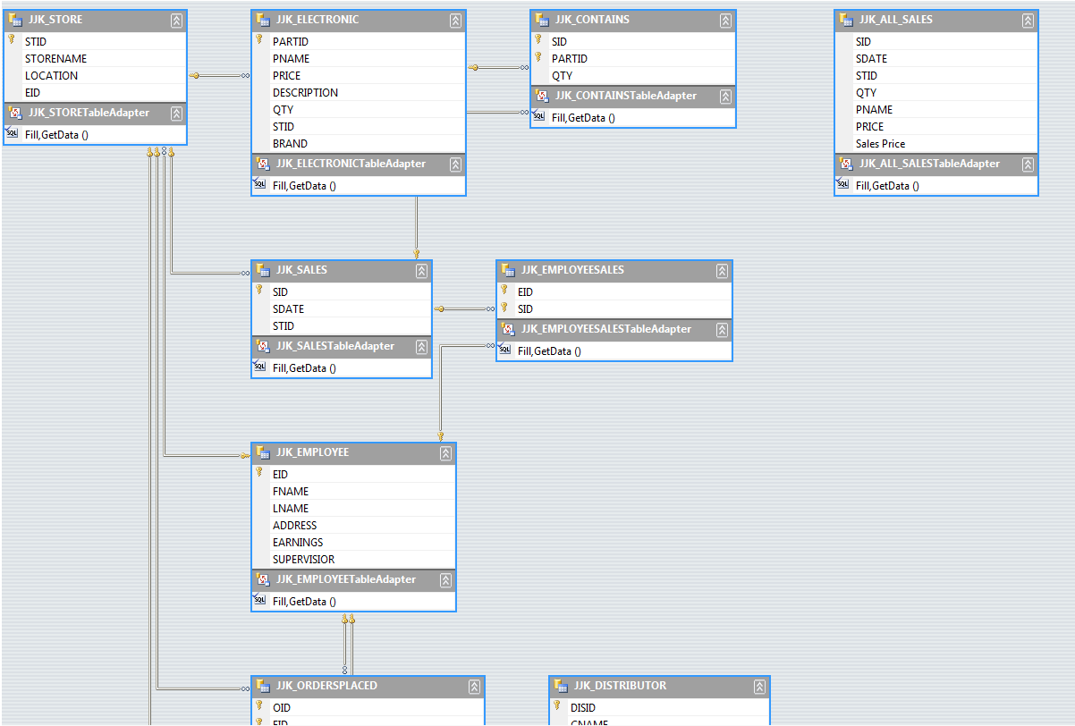
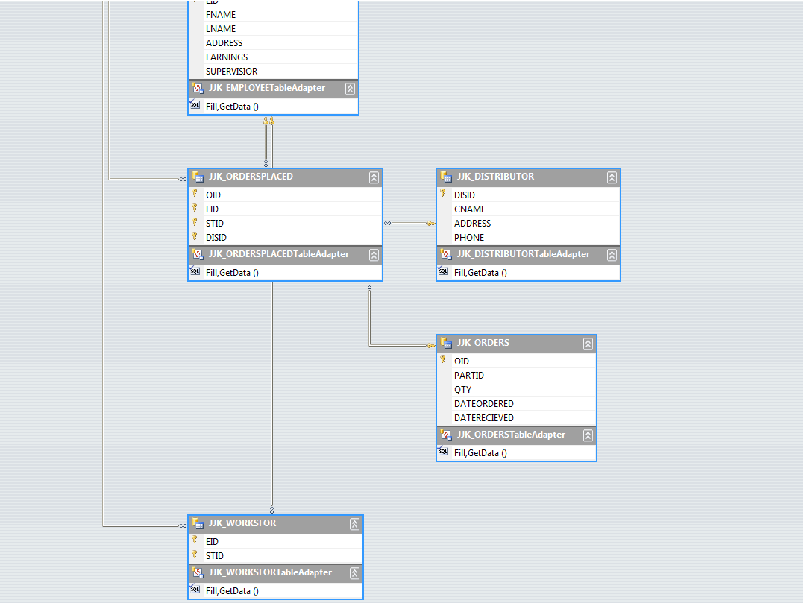
5.6 Screen shots
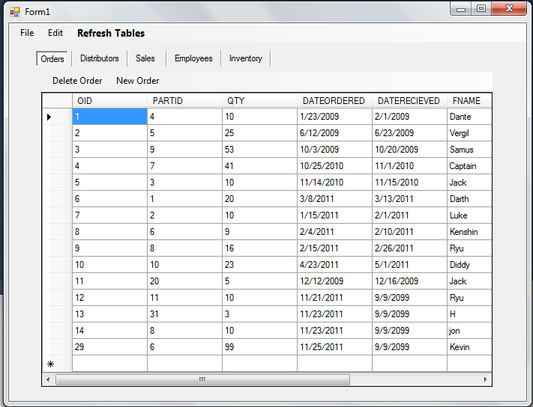
This is the screenshot of our orders table being displayed. The user can access the orders that were placed and the different things in that table such as the date ordered and the date received. If you scroll to the right you can also see the person who placed the order and the distributor it was ordered from.
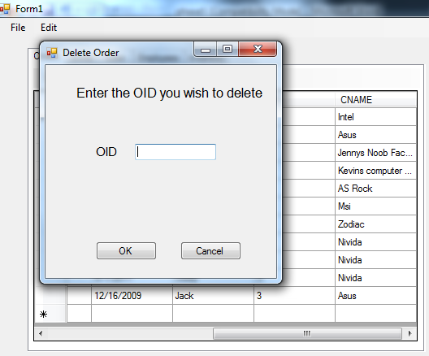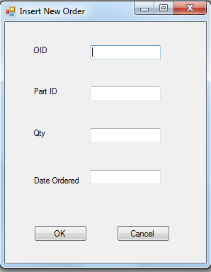
If you click on delete you can enter the order ID and delete it when you push ok. If you push insert new order the following display will open up where you can enter the order ID, Part ID, Qty, and Date Ordered then click ok. To see the new orders table with the changes that have been made, you can click on the refresh tables button.
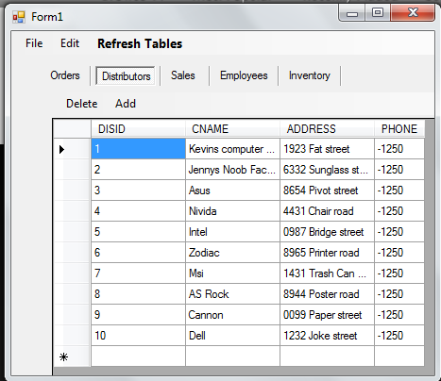
We similarly did the same thing for our stores, employees, and inventory. The attributes for the corresponding tables were also adjusted for the add, delete, and refresh.
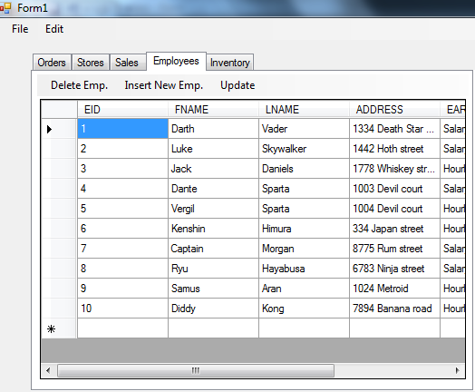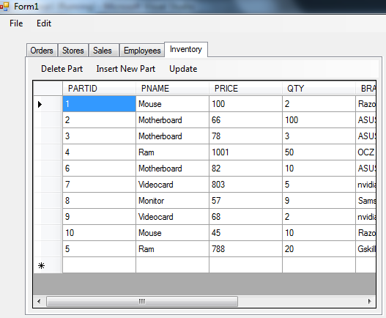
For sales, the group made it similar as well. However, adding sales is different because we made it into two steps because with one we were not able to add multiple sales with one step.
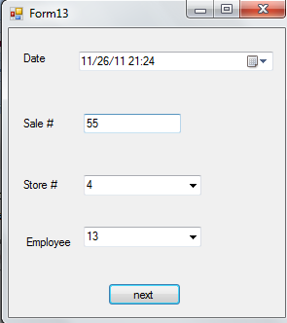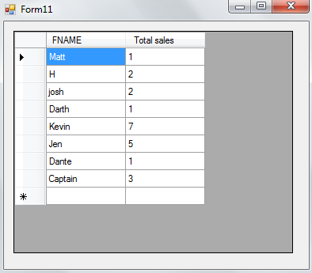
Above is the first step. This is an employee performance report.
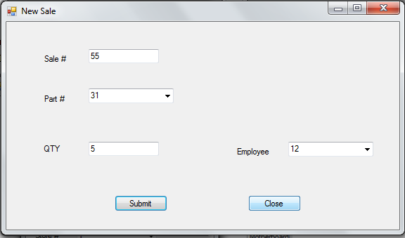 This is the next step where you can add more parts.
5.7 Major steps in designing and implementing database application
Learning and developing code in a new development tool and programming language in a short amount of time has proven to be difficult. There will be more times for computer scientist who will be faced with such difficulties. While both of these were proven difficult, there were also strict guidelines enforced.
Learning Microsoft visual studios was hard to understand. The hardest part was getting a connection from the oracle database to out c# program. After many hours of trying to connect we figured out that one of the problems was using a 64bit oracle client was the issue. After switching to the 32bit the difficulty went down slightly. Visual studios generated a lot of code for us to use when we were creating buttons for our GUI. This was both good and bad. Good because it made it a bit easier to know where our code and functions went. Bad because it seems buggy and lots of error handling is required.
Coding in c# itself isn’t too hard. The syntax is very similar to coding in c++. After taking a few programming classes and understand the general concepts of programming, c# was understood swiftly.
Designing and implementing is very important from the conceptual model. A very well planned out conceptual model will prevent rework and time wasted on the database. With good planning stored procedures and tables will make working on the database easier. Without good planning working on a database would consume endless amount of time and work.
Once you have the tables made, next step is to create relationships for the tables. This is an important step. Knowing how the tables relate is important. This is will prevent data duplication and improve efficient in the database. Poor relationship creation will create lots of duplicated data or headaches.
After the tables and relationships are step up, the next thing a person would want to do is to make stored procedures. Stored procedures are useful for reducing the work on the front of the applications. This will make your code more efficient and make it flow more efficiently.

5.8 MAJOR FEATURES OF THE GUI
First, GUI stands for graphical user interface. It enables users to be able to interact with electronics through something else besides just text.
Our GUI is very easy to use. One thing we would like to improve, if we had more time, would be the names when adding employees instead of using the number. In our GUI 9/9/2099 for the date received is a stored date meaning that we have not received those parts yet. When we receive the part, the date received can be changed.
We tried to make our GUI as user friendly as possible. There are screenshots of what our GUI looks like above in the screen shot section. We were able to do most of the things we wanted but with more time, we can make it much better.
5.9 LEARNING A NEW DEVELOPMENT TOOL AND WRITING CODE IN A NEW LANGUAGE
For our database we had to use Visual Studios 2010, Oracle, and SQLPlus. For C#, the syntax was not very difficult; however using the Visual Studious to import different procedures was very difficult because we did not really have clear instruction on how to do so. We only had example code that helped with some, but not help with other parts. C# we had looked at over the summer before we started school. As for SQL Plus on Delphi that was also not very hard it was just time consuming. The SQLPlus part of our database was the fun part of creating our database.
Using Visual Studios to make a connection between Delphi and oracle was much more challenging than we had anticipated. One thing that we wish was different was spending less time on the queries on paper so we could have more time to do phase 5, which was the longest and hardest phase that we only had the last week to do.
To help us during the coding of this phase we looked online to different websites such as learnvisualstudios.com, www.microsoft.com/visualstudio/en-us, and vslive.com/events/orlando-2011/home.aspx. We also checked out different forums that had different problems that we had issues with.

