Table Of Contents
Phase I: Information Gathering and E-R Modeling

Techniques Used 2
Introduction to Enterprise/Organization 3
Structure of Enterprise 3
Itemized Description of Major Objects 3
Data Views and Operations for user Groups 4
Entity Set Description 5
Employee 5
Restaurant 6
Skill 7
TaskTeam 8
Relationship Set Description 9
E-R Diagram 10

Phase II:E-R Conversion
E-R Model VS Relational Model 11
Comparison 11
Conversion 11
Constraints on the Relational Model 12
Employee Relation 13
Restaurant Relation 14
Skill Relation 15
TaskTeam Relation 15
Member_Of Relation 15
HasLearned Relation 16
IsNecessaryFor Relation 16
Employee Instance 17
Restaurant Instance 17
Skill Instance 18
TaskTeam Instance 18
WorksFor Instance 19
Memberof Instance 19
HasLearned instance 20
IsNecessaryFor Instance 20 Queries 21

Phase I

Initial Description

Fact Finding Techniques and Information Gathering

In this part of the phase, we will be gathering all of the information needed in order to create our conceptual database. This step is very important because in order create a functioning logical database, we must begin with first gathering all of the needed information and not leaving out any necessary information that could jeopardize the database as the process progresses.

1.1 Description of Fact finding techniques
In order to gather the best information possible, we must first consider what business we will be modelling. For our business, which will be the hamburger chain restaurant discussed earlier, we must consider that there are different types of employees that have different responsibilities and some will be in charge of other employees. The methods of Gathering information will include:

-Reading Company Policy
The company policy on how employees should perform and how they should act will be necessary in understanding the way the company runs. The policy will provide us with the basic and simple understanding of how the company should work. However, it will not be sufficient for a complete understanding of how the company works, as a company doesn’t always work the way int should.

-Interviewing
Interviewing the individual employees will provide a more direct approach to understanding how the company policies are implemented in real life. Interviewing the employees won’t allow everyone to give their input, however, because there are will be too many people to interview and not all employees will have the time to give their input. This will however, be the best way to provide the employees to make known any concerns they may have about the

-Surveys
Simple surveys will provide everyone a chance to give their input about how a hamburger restaurant works and how a database should be created to suit their needs. There will not be as much detail as the interview process but this may still catch some important aspects of the restaurant that missed.

All of these methods of collecting data provide us with a way of understanding how this business works and allows us to create a conceptual idea of how the database will ultimately look like when completed.

The data that is collected from these techniques can be used to identify all of our entities that will be used for creating out database. From this information, we will also be able to gather all the needed attributes of their entities. We will also be able to identify that relationships between our entities to being implementing our database.

1.3 Introduction to Enterprise/Organization
The Enterprise which I will be creating a database for will be a hypothetical chain hamburger restaurant, similar to the many fast food restaurants that exist today such as McDonalds or Burger King. To allow simplicity, the database will not apply to a global scale but instead be created with a more local scaled design on this restaurant.

1.4 Structure of the Enterprise
The hamburger chain restaurant works as follows. There company is organized into three different regions, each of which has their own unique number of restaurants. Each of these regions is also responsible for providing service to their own geographical area.

The company is headed by a company president who makes company-wide decisions. Below the president are the regional managers who are in charge of their own regions, making decisions that affect only those in that region. Below the regional manager are local managers who are in charge of their assigned restaurant and the employees within it. Each restaurant has their own number of cashiers, cooks, and maintenance employees. The number of employees depends on the size and activity of the restaurant’s location.

The employees of the company include those who work on a local level to the managers and the president. Each employee’s name, Social Security Number, Address, the date they began working, the date they ended working, and their disciplinary history.

For the purposes of this database, we will only focus on one individual region with different restaurants serving a variety of different meals.

1.5 Itemized Descriptions of major objects, and the relationship among(or between ) the objects in the business.
The most basic entity for the conceptual database will be the employee entity. Since there are many jobs in a restaurant such as this, each employee will be capable of certain duties and this will be identified by a skill entity in the database. There will be other basic information about the employee in the Employee Entity. There will also be a restaurant entity to specific restaurant within the region. The restaurant entity will contain information about what entity it is, who runs the restaurant, and who works in the restaurant. A skill entity will also be created to specify which employees are capable of which skills. In a restaurant, some skills are necessary to perform certain tasks. A cook needs to know how to cook well, a manager needs to know how to manage, a cashier needs to know how to use the cash register, etc.

1.6 Data views and operations for user groups
In the restaurant, different employees have different responsibilities that they must attend to. The cook, must make sure that the food that is being ordered is being cooked and delivered. The Cashier must be aware of the cash flow, what is being ordered, and make sure that the customers are satisfied. The regional manager must ensure that the local managers of the restaurants are doing their jobs properly and ensure that there are no problems, along with other executive responsibilities. The local manager must ensure that employees arrive on time, that the employees are doing their jobs, among other responsibilities.

2.1 Entity Set Description

Employee Entity
The employee key will be the most basic entity which will be used to identify the individual employees which will be working in a particular restaurant which is in a particular region. The entity will interact with other entities through relations to ultimately create the database.

--candidate keys:EmpID, SSN, Name
--primary key: EmpID
--Strong/Weak Entity:Strong
--Fields to be indexed:EmpId, Name
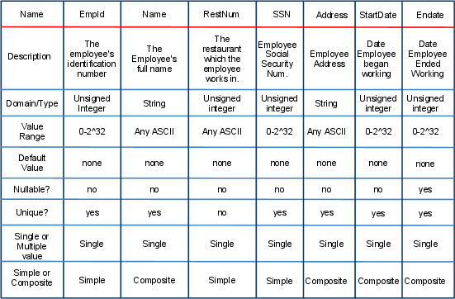

Restaurant Entity
The restaurant entity will be used to identify each individual restaurant and to interact with the other entities to create the database. The entity keeps track of things that go on in the individual restaurants such as who has worked there, who is the manager, and the sales of that particular restaurant.
candidate keys:RestNum, RestAddress
primary key: RestNum
Strong/Weak Entity: Strong
Fields to be indexed:RestNum, Employees
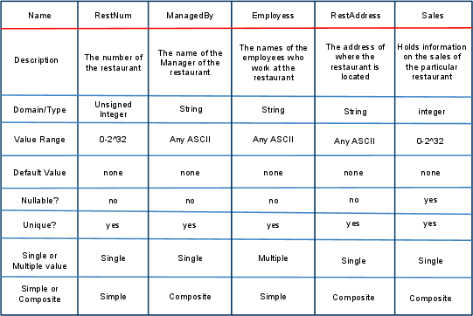

Skill Entity

candidate keys:SkillNum, Name
primary key:SkillNum
Strong/Weak Entity:Strong
Fields to be indexed:SkillNum, EmpList

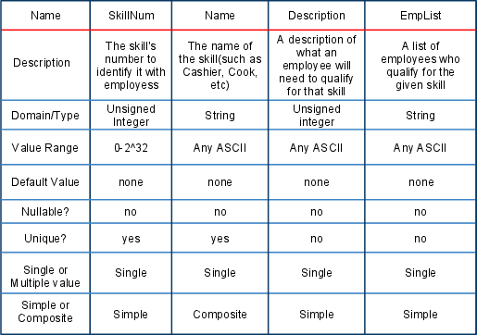

TaskTeam Entity
The TaskTeam Entity is a team of employees that is responsible for doing a certain task. An employee must belong to a taskteam when they are working and that team is responsible for certain duties.

candidate keys:TaskTeam Name
primary key:TaskTeam Name
Strong/Weak Entity:Strong
Fields to be indexed:TaskTeam Name
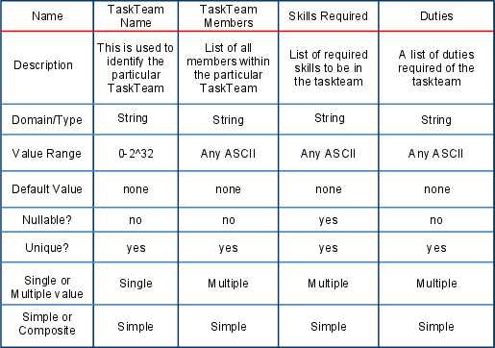

Relationship Set Description
Work_For:
This relationship shows us what particular restaurant an employee works for. It is important to have this relationship to understand which employees are working in which restaurants and understand what they are doing in that restaurant. All employees must be working at some restaurant and must be doing a particular job at that restaurant.
Mapping cardinality: M:M
Descriptive field: None
Participation Constraint:Mandatory for Employee, Optional for Restaurant
Member_Of

The member_of relationship shows which taskteam an employee is in. All employees must be in a task team at all time but can only be in one task team at a time. In order be within, an employee is required to have the skill associated with that taskteam.
Mapping cardinality: M:M
Descriptive field: None
Participation Constraint:Mandatory for Employee, Optional for TaskTeam

Learns
Learns is a relationship between an employee and a skill. Each employee must have at least one skill at all times in order to participate. One an employee has a skill, the employee can be a member of the task team associated with that skill.
Mapping cardinality: M:M
Descriptive field: None
Participation Constraint: Mandatory for Employee, Optional for Skill

Is_Necessary_For
This relationship makes it necessary to have a skill before an employee can become a part of a task team. An employee must have a certain skill before they can be a part of any task team.
Mapping cardinality: M:M
Descriptive field: None
Participation Constraint: Mandatory for both skill and TaskTeam

2.4
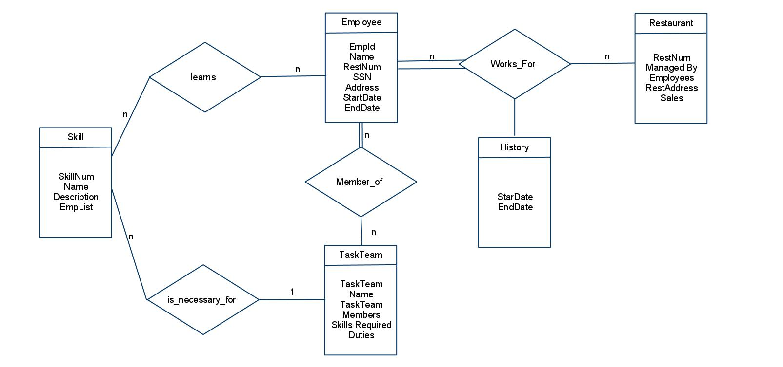

Phase II

ER model vs. Relational Model
The E-R model is helpful for having an initial visualization of what our database will look like and how that database will function. This model, however is not suitable for creating a database as not enough information is given about each entity and its attributes and how it relates to other entities and their attributes. The relational model provides a more detailed and logically oriented database conception which will be much easier to convert to to an actual physical database, since DBMSs rely on the same logical principles as the relational model relies on. The only change necessary will be to convert the Relational model language to the language of the DBMS.

Comparison
The E-R model serves as a representation of the entire database to get you started with creating the database. It contains entities and their attributes and also contains the relationships between those entities and how they function with each other. Because of its simple nature, the E-R model can be used, to some extent, to show inexperienced people, such as your who is not technically knowledgeable, how the database will function. The model, however, will not really contain any any of the important information to directly translate into an actual database as the relational model will.

The relational model takes a different approach than the E-R model in organizing the information and in allowing the user to access the information. The relational model uses tables with tuples to describe the database and allows the user to perform logical operations on the tables in a similar fashion that databases do. One of the advantages of the relational model is that the creator of the database can better visualize what the actual database will be and how it will function by attempting some logical queries on the tables which can be more easily converted into a whatever database language is necessary. One of the disadvantages of having the relational model is that it is a bit more complicated than E-R model which makes it more difficult for a person with not experience to fully understand the intended database and the what is possible with that database.

Conversion from E-R model to relational model
A conversion fromt the E-R model is a stepping stone to get to the actual database. The conversion is needed in order to better understand how the database will function and to allow the creator of the database to see what kind of queries will be possible and how those queries will be formed logically.

To convert the E-R model, the first thing we must look at in the E-R model will be the different entities that exist withing the E-R model. The strong entities are especially important since they will be the main source of the database and is where all functions in the database will be carried. A relational table must be created for the strong entities using the relational model in order to allow for the creation of these relations in the actual database. A primary key will be necessary for each of the relations in order to be able to identify each specific relation. Basically, the strong entities can be converted into a table with the attributes of that entity being the columns of that relation, and the primary key can be inherited so that it will be the same as in the E-R model. To convert weak entities, we must do the same as we did with the strong entities but to obtain the primary key, we must combine the partial key of the weak entity with the primary key of the strong entity of which it is dependent.

For 1:1 relationships, there are three different approaches that can be taken to make the conversion to a relation. The approaches are the Foreign key approach, the Merged relation approach, and the cross-reference approach. The foreign key approach is to place the primary key of one of the relations and make that the foreign key of the other relation. This is best done when there is total participation in the relation. For the merged relation approach, both entities are merged to create a single relation. This approach is only possible if there is total participation from both sides so that there both tables have the exact number of tuples. Finally, for the cross-reference approach, an extra relation is created, called the relationship relation, to cross-reference both of the relations. This relation will have both of the primary keys of the other two relations as its foreign keys. The cross-reference approach will be necessary for the M:N relationship.

For 1:N relationships, the primary key of the 1-side is placed in the N-side as a foreign key, so that each entitiy instance on the N-side is related to at most one entity instance on the other side. For the M:N relationship, the cross-reference approach described above is used.

For multivalued attributes, a new relation can be created which will contain an attribute that corresponds to the initial attribute and the primary key of the relation that the attribute came from. These two can be combined to form a primary key for the new relation.

It is also important to note that when it comes to superclasses and subclasses, a new relation must be created for every subclass that the superclass has. When creating the attributes of the subclass, one must also include that were present in the superclass that the subclass belongs to.

Doing everything described will result in a conversion of the E-R model to the relational model.

Constraints of the relational model
All relations may have different constraints on them which prevent them from doing certain tasks that would be illogical and not allow the relation to function properly. Entity Constraints are those that prevent an entity from doing that something should not be. One of the most important entity constraints is that of preventing a primary key from being NULL, as thing would render it unable to relate to other relations. Primary key constraints are those that make only one primary and prevent any other primary keys. Referential and business constraints are those that prevent make data more specific. Such as making a date only six digits. Candidate keys those are attributes that can serve as a primary key, however, there must only be one primary key for each relation so that other relations can directly refer to that relation.

Converting the E-R Database to Relational Database
Employee Relation

Attributes
-EmployeeID
Domain: Unsigned Integer, within range of 1-2³²-1, and cannot be null since it will be the primary key.
-Name
Domain: String, first name and last name seperated by a space. Can never be null since everyone must have a name and the must be the same name at all times.
-SSN
Domain: Unsigned integer,1-2³²-1, must be exactly 9 digits long since that is the only size the government allows, cannot be null since everyone must have their SSN file while they work in the restaurant.
-Address
Domain: String, may contain both letters and numbers. Contains the address in which the employee is currently living in . Cannot be null.
-StartDate
Domain: unsigned integer,1-2³²-1, contains the date in which the employee starts working. Must Contain exactly 6 digits containing the month, day, and year for which the employee began to work in the restaurant. Cannot be null.
-EndDate
Domain: Unsigned integer, 1-2³²-1,contains the date in which the employee stopped working in the restaurant. Can be null.

Constraints
Primary Key: The Employee ID will act as a primary key for the relation to be able to relate to other relations.

Business Rule: The start date must be less than the end date.
Candidate Keys
These can all act as primary keys but the EmployeeID will be used as the primary key for this.

-EmployeeID
-SSN
-Name

Restaurant Relation
Attributes:
-RestNum
Domain: Unsigned Integer, 1-2³²-1, acts as primary key to the relation.
Can never be null.
-RestAddress
Domain: String, Contains the physical address of the restaurant. Can never be null and should never be changed.
-ManagedBy
Domain: Unsigned Integer, Contains the id of the current manager of the restaurant. Can never be null.
-Sales
Domain: Unsigned Integer, 1-2³²-1, Contains the sales made for the current month.
Constraints:
Primary Key: Restnum is the primary key for the relation.
Foreign Key: The number in ManagedBy must also be present as an EmployeeID.
Candidate Keys:
The following are Candidate keys but Restnum is the primary key.
-RestNum
-RestAddress

Skill Relation
Attributes:
-SkillNum
Domain: Unsigned integer, 1-2³²-1, acts as the primary key of the relation. Can never be null.
-Name
Domain: string, contains the name of the skill that the relation is describing, not restrictions except that it cannot be null.
-Description
Domain: string, holds the description of the skill that will be available to the employees.

Constraints:
Primary Key: The skillnum is used as the primary key for this relation.
Candidate Keys:
-skillnum
-Name

TaskTeam
Attributes:
-TaskTeamNo
Domain: Unsigned Integer, 1-2³²-1, acts as primary key for the relation. I used as an identifier for the team. Cannot be null.
-TeamName
Domain: String, no restrictions except that it cannot be null.
-SkillsRequired
Domain: String, contains the skills necessary to be a part of the taskteam.
Cannot be Null.
-Duties
Domain: string, contains the duties that the task team will perform.
Constraints:
Primary Key: The primary key will be TaskTeamNo, which will be used to relate to other relations.
Candidate Keys:
-TaskTeamNo
-TeamName

Works_For
Attributes:
-EmpID
Domian: Unsigned Integer, 1-2³²-1, Cannot be Null.
-RestNum
Domian: Unsigned Integer, 1-2³²-1, Cannot be Null.
-StartDate
Domain: Unsigned Integer, 1-2³²-1, must be 6 digits long and correspond to a date with day, month, and year(e.g. 11/13/07), Cannot be Null.
-EndDate
Domain: Unsigned Integer, 1-2³²-1, must be 6 digits long and correspond to a date with day, month, and year(e.g. 11/13/07).
Constraints:
Foreign Keys: EmpID should exist in the employee relation and RestNum should exist in the restaurant relation.

Business Rule: The start date must be less than the end date.
Candidate Keys:
The are no candidate keys since it corresponds to a relationship set.

Member_Of
Attributes:
-EmployeeID
Domain: Unsigned Integer, 1-2³²-1, Must Never be Null.
-TaskTeamNo
Domain: Unsigned Integer, 1-2³²-1, Must never be Null.
Constraints:
Foreign Keys: Employee ID must exist in the Employee Relation and TaskTeamNo must exist in the TaskTeam Relation.
Candidate Keys:
The are no candidate keys since it corresponds to a relationship set.
Has_Learned
Attributes:
-SkillNo
Domain: Unsigned Integer, 1-2³²-1, Must Never be Null.
-EmployeeID
Domain: Unsigned Integer, 1-2³²-1, Must Never be Null.
Constraints:
Foreign Keys: The skill number must exist in the skill attribute and the Employee ID must exist in the Employee Attribute.
Candidate Keys:
The are no candidate keys since it corresponds to a relationship set.
Is_Necessary_For
Attributes:
-SkillNo
Domain: Unsigned Integer, 1-2³²-1, Must Never be Null.
-TaskTeamNo
Domain: Unsigned Integer, 1-2³²-1, Must Never be Null.
Constraints:
Foreign Keys: SkillNo must exist in the skill relation and TaskTeamNo must exist in the TaskTeam relation.
Candidate Keys:
The are no candidate keys since it corresponds to a relationship set.

Relation Instances(Tuples and Table Body)

Employee Instance
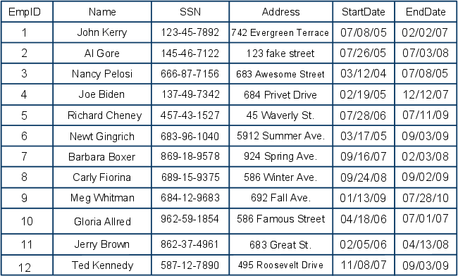

Restaurant Instance
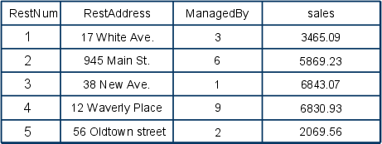

Skill Instance
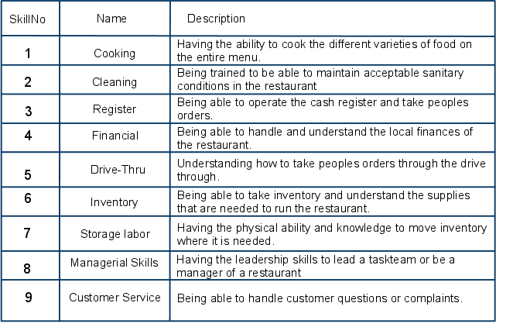

TaskTeam Instance
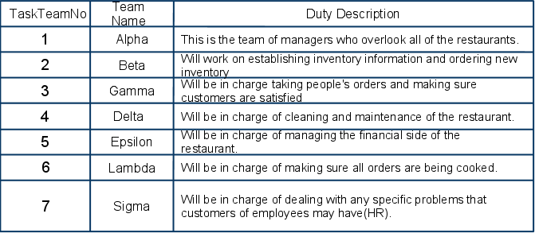

Works_For
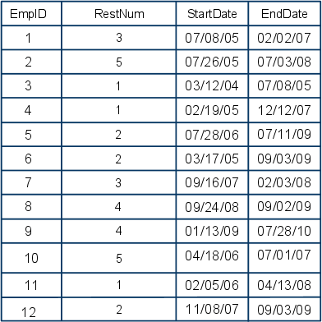

Member_Of
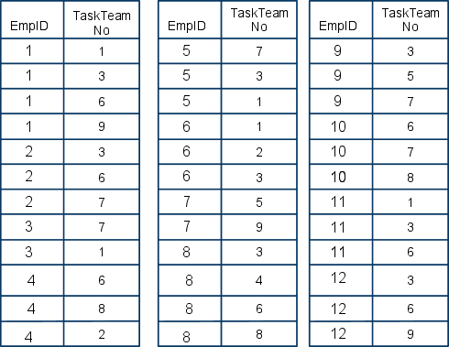

Has_Learned
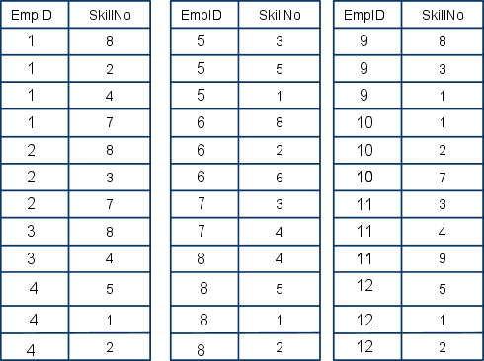

Is_Necessary_For
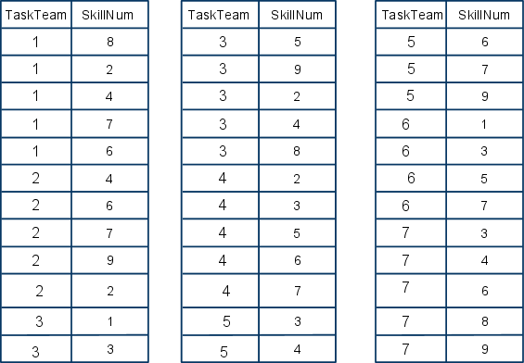

Queries
1. List Employees who have at least one skill.
2. List Employees who have worked between 01/01/05 to 01/01/06.
3. List taskteams that have one employee.
4. List taskteams that have all employees.
5. List taskteams that require two skills.
6. List Employees who have had more than one manager.
7. List skills that all employees have.
8. List employees who are in Meg Whitman’s Team

Relational Algebra
1. π(EmployeeID)(Employee - π(EmployeeID)(Employee * σ(skill > 1)Has_Learned))
2. π(EmployeeID)(σ(sdate > 010105 AND edate < 010106)(Employee))
3.π(TaskTeamID)TaskTeam * (σ(EmployeeID != Null)(Employee))
4.π(TaskTeamID)(taskteam * (σ(EmployeeID != EmployeeID2)(Employee)))
5.π(TaskTeamID)(skill * (σ(skillNo >1 AND skillNo<3)(Skill)
6.π(EmployeeID)(σ(ManagedBy > 1)(Restaurant))
7.π(SkillNo)(σ(EmployeeID >1)(Employee))
8. π(EmployeeID)( Employee ÷ Works_For * (σ(Name = “Meg Whitman)(Employee)))

Tuple Relation Calculus
1. {e | Employee(e) ^ (∃p)(Has_Learned(p) ^ p.EmployeeID = e.EmployeeID) }

2. {e | Employee(e) ^ (∃p)(WorksFor(p) ^ p.StartDate > 010105 p.EndDate < 010106 ^ p.EmployeeID = e.EmployeeID )}

3. {t | taskteam(t) ^ (∃e(Employee(e) ^ p.EmployeeID != NULL ) }

4.
{t | TaskTeam(t) ^ (∀e)(Employee(e) ^ e.EmployeeID = t.EmployeeID) }

5.
{t | TaskTeam(t) ^ (∃e)(IsNecessaryFor(e) ^ (∃f(IsNecessaryFor(f) ^ e.TaskteamID = t.TaskteamID ^ f.TaskTeamID = t.TaskteamID ^ e.TaskTeamID != t.TaskTeamID) }

6.
{e | Employee(e) ^ (∃r)(Restaurant(r) ^ (∃s)(Restaurant(s) ^ s.ResNum != r.RestNum ^ r.Managedby != e.employeeID ^ s.ManagedBy != e.employeeID) }

7.
{s| Skill(s) ^ (∀e(HasLearned(e) ^ e.EmpoyeeID = s.EmployeeID))

8.
{e | Employee(e) ^ (∃p)(Member_of(p) ^ p.EmployeeID = 9 ^ p.TaskTeamID = e.TaskTeamID ) }

Domain Relational Calculus
1.{<e> | Employee (e,_,_,_,_,_) ^ (∃s)(Has_Learned(e,_) }

2.{<e> | Employee(t,_,_,_,s,f) ^ s > 010105 ^ f < 010106 }

3.{<t> | TaskTeam (t,_,_) ^ (∃e)(Member_of(t,s) }

4.{<t> | TaskTeam (t,_,_) ^ (∀e)(Member_of(t,s) }

5.{<t> | TaskTeam (t,_,_) ^ (∃e)(IsNecesasryFor1(_,s) ^ (∃p)(IsNecessaryFor2(_,s) ^ p !=e) }

6.{<e> | Employee (t,_,_,_,_,_) ^ (∃e)(Restaurant(_,_,m,_) ^ (∃p)(Restaurant(_,_,m,_) ^ p !=e) }

7.{<s> | skill (s,_,_) ^ (∀e)(Employee(t,_,_,_,_,_) }

8.{<e> | Employee (t,_,_,_,_,_) ^ (∃e)(member_of(_,t) ^ t = “Meg Whitman”}

Phase II: Creating a physical logical database using Oracle

Purpose of SQL plus
The main purpose of sqlplus is to be able to create our physical and logical database and to manipulate it. Using this software, a person can use their relational model and convert into a SQL database and better interact with the database. SQL stands for Structured Query Language and is used to perform various tasks on objects in database. With SQL, one can create a table, insert into the table, delete the table, and create different schemas and interact with them. While there are several versions of DBMSs that use SQL, I will be using the Oracle Relational Database Management system. With SQLplus, one can interact with the database similarly to the way one would interact with a command line. Creating tables this way can be very tiring and time consuming, so the user is able to create a file with several commands, and run them all at once by simply running that file. In this way, a user can fill a table, delete a table, delete all tables, create all tables, fill all tables, or perform several other functions, simply by running file. This can be very valuable when changes need to be made to entire database and the user does not wish to re-enter several values repeadedly.

Schema Objects allowed in Oracle Database
Schema objects are objects in the database which perform certain tasks for the user within the database and which allow the database to function efficiently.

Tables:
Tables are the most basic and funcdamental schema that exist within Oracle. Most interaction with the database will involve interaction with tables within the database. Tables are easily created using the SQLplus create command. With this command, the user can create the columns that will exist within the table, identify the datatype that the column will use, identify which column will contain the primary and foreign keys, and create constraints such as identifying which colums cannot contain ‘null’. After the user has created these columns, the user can then start inserting actual data in the tables in the form of tuples. This can be done using the insert command by typing the name of the table for which you wish to enter data, enter the word values and then typing out the that you wish to be entered in parenthasis.

Views(Including Materialized Views)
Views are simple read-only Queries that will return only parts of a larger table, sometimes known as a base table, so that it essentially gives you only a smaller view of the actual base table. While this is only a view of the larger table, users are still able to add and delete from this this table as may be necessary. Unlike their base tables, views, do not occupy any actual space but exist only as queries, while the actual space occupied for the view exists solely in the base table. Although constraints and triggers cannot be used directly on the view, the constraints and trigger of the base table will also apply to the view when the user interacts with them. Views can have several different uses, such as only allowing certain information to be accessed by a certain users or to simplify the table so that an average user can understand it. Materialized view are views that will actually perform some specified function the data as it is entered, such as calculating something as the numbers are entered into the table.

Dimensions
A dimension create a parent/child, otherwise known as hierarchical, relationship between two columns in a table. With dimensions, we can create dependencies between the levels of the child column and of the parent column. Since a dimension exists only as that relationship between the columns it was assigned, it isn’t physically stored anywhere.

Sequence Generator
Sequence Generators create a stream of sequential numbers that can be used when creating a database. Sequence generators can be useful because they allow a user to generate a unique number for the sequence and make that number only available for the session that the user is using. This prevents different users from having the same number. The sequence numbers can also be used to create primary keys, since it will create a unique key for every row in the table. Though the generator will not use the table in any way to create the number.

Synonyms
Synonyms are different names that can be used for other schemas for several different purposes. Since they are only alternate names for actual schemas, they do not require any additional space to store since the actual data already exists in the original schemas. Some of the schemas for which synonyms can used include a table,a view, procedure, a package, etc. Synonyms can be useful for security purposes (hiding important names) or simply to allow other users to more easily read the table.

Indexes
While most databases, including the oracle database, use primary keys to access information in a timely manner, there are other, more efficient methods that can be used to more quickly access data. With oracle,a user can declare an index between two different columns and reduce disk i/o and ultimately making data access faster. Indexes do not directly affect any of the tables in which it is used on, so they can be dropped at any time without negatively affecting the actual table. There are several different types of indexes that can be used in oracle which include B-tree, hash cluster, and many other types of indexes.

Stored Functions/Procedures
Stored functions and Procedures are a set of instructions within a file that will do whatever is specified in the instructions if the file is ran. These can be useful for performing several functions with one command as opposed to having to use several commands to complete one task.

Packages
A package is a large group of functions, procedures, SQL statements, and variables that are used for accomplishing large scale tasks. Packages can be useful, and are sometimes necessary, when large projects are being created and several tasks need to be performed at the same time. This can be done instead of doing each individual task one by one.

Database Links
Database links are links made from one database to another. This allows both databases to communicate effectively without compromising both individual databases. This can be useful when information from both databases are needed.

The following syntax was used to create the tables for:

create table [Name of Table](attribute_name1, data_type1, primary_key?, NULL?,
attribut_name2, data_type2, primary_key?, NULL?,
...
...
);

To insert tuples into the tables, the following syntax was used:
insert into [Name of Table](value1, value2, value3,...valueN)--N = number of values in row

MB_Employee
Name Null? Type
----------------------------------------------------------------- -------- ------------------------------------ --------
EMPLOYEEID NOT NULL NUMBER
NAME NOT NULL VARCHAR2(50)
SSN NUMBER
ADDRESS VARCHAR2(50)
STARDATE DATE
ENDDATE DATE

EMPLOYEEID NAME SSN
---------- -------------------------------------------------- ----------
ADDRESS STARDATE ENDDATE
-------------------------------------------------- --------- ---------
2 Al Gore 145467122
123 fake street 26-JUL-05 03-JUL-08

12 Ted Kennedy 587127890
495 Roosevelt Drive 08-NOV-07 03-SEP-09

3 Nancy Pelosi 666877156
683 Awesome St. 03-DEC-04 08-JUL-05

4 Joe Biden 137497342
684 Privet Drive 19-FEB-05 12-DEC-07

5 Richard Cheney 457431527
45 Waverly Place 28-JUL-06 11-SEP-09

6 Newt Gingrich 683961040
519 Summer Ave. 17-MAR-05 03-SEP-09

7 Barbara Boxer 869189578
924 Spring Ave. 16-SEP-07 03-FEB-08

8 Carly Fiorina 689159375
586 Winter Ave. 24-SEP-08 02-SEP-09

9 Meg Whitman 684129683
692 Fall Ave. 13-JAN-09 28-SEP-10

10 Gloria Allred 962591854
586 Famous St. 18-APR-06 01-SEP-07

11 Jerry Brown 862374961
683 Great St. 05-FEB-06 13-APR-08

1 John Kerry 123456789
742 Evergreen Terrace 07-OCT-05 02-FEB-07

MB_Has_Learned
Name Null? Type
----------------------------------------------------------------- -------- --------------------------------------------
SKILLNO NOT NULL NUMBER
EMPLOYEEID NOT NULL NUMBER

SKILLNO EMPLOYEEID
---------- ----------
1 8
1 2
1 4
1 7
2 8
2 3
2 7
3 8
3 4
4 5
4 1
4 2
5 3
5 5
5 1
6 8
6 2
6 6
7 3
7 4
8 4
8 5
8 1
8 2
9 8
9 3
9 1
10 1
10 2
10 7
11 3
11 4
11 9
12 5
12 1
12 2

MB_Is_Necessary_For
Name Null? Type
----------------------------------------------------------------- -------- --------------------------------------------
SKILLNO NOT NULL NUMBER
TASKTEAMNO NOT NULL NUMBER

SKILLNO TASKTEAMNO
---------- ----------
1 8
1 2
1 4
1 7
1 6
2 4
2 6
2 7
2 9
2 2
3 1
3 3
3 5
3 9
3 2
3 4
3 8
4 2
4 3
4 5
4 6
4 7
5 3
5 4
5 6
5 7
5 9
6 1
6 3
6 5
7 7
7 3
7 4
7 6
7 8
7 9

MB_Member_Of
Name Null? Type
----------------------------------------------------------------- -------- --------------------------------------------
EMPLOYEEID NOT NULL NUMBER
TASKTEAMNO NOT NULL NUMBER

EMPLOYEEID TASKTEAMNO
---------- ----------
1 1
1 3
1 6
1 9
2 3
2 6
2 7
3 7
3 1
4 6
4 8
4 2
5 7
5 3
5 1
6 1
6 2
6 3
7 5
7 9
8 3
8 4
8 6
8 8
9 3
9 5
9 7
10 6
10 7
10 8
11 1
11 3
11 6
12 3
12 6
12 9

MB_Restaurant
Name Null? Type
----------------------------------------------------------------- -------- --------------------------------------------
RESTNUM NOT NULL NUMBER
RESTADDRESS NOT NULL VARCHAR2(30)
MANAGEDBY NOT NULL VARCHAR2(30)
SALES NOT NULL NUMBER

RESTNUM RESTADDRESS MANAGEDBY SALES
---------- ------------------------------ ------------------------------ ----------
1 17 White Ave. 3 3465.09
2 945 Main St. 6 5869.23
3 38 New Ave. 1 6843.07
4 12 Waverly Place 9 6830.93
5 56 OldTown Street 2 2069.56

MB_Skill
Name Null? Type
----------------------------------------------------------------- -------- --------------------------------------------
SKILLNUM NOT NULL NUMBER
NAME NOT NULL VARCHAR2(20)
DESCRIPTION VARCHAR2(60)

SKILLNUM NAME DESCRIPTION
---------- -------------------- ------------------------------------------------------------
1 cooking being able to cook items on menu.
2 cleaning Being trained in how to properly clear restaurant
3 register Being trained in how to properly used register
4 financial Being trained in the financial happenings of business.
5 Drive Thru Being able to operate the drive through
6 Inventory Being able to handle restaurant inventory
7 storage labor Being able to physically handle storage of supplies.
8 Managerial Skills Being able to handle managing the restaurant.
9 Customer Service Being able to handle customer question or complaints.

MB_TaskTeam
Name Null? Type
----------------------------------------------------------------- -------- --------------------------------------------
TEAMNO NOT NULL NUMBER
TEAMNAME NOT NULL VARCHAR2(15)
DUTIES NOT NULL VARCHAR2(60)

TEAMNO TEAMNAME DUTIES
---------- --------------- ------------------------------------------------------------
1 alpha Team of managers who manages restaurants.
2 beta Establishes and replenishes inventory.
3 gamma Takes orders and makes sure customers are satisfied.
4 delta Cleans and Maintains sanitation of restaurant.
5 epsilon Manages Restaurant finances.
6 lambda Cooks orders.
7 sigma Handles customer relations
MB_Works_For
Name Null? Type
----------------------------------------------------------------- -------- --------------------------------------------
ID NOT NULL NUMBER
RESTNUM NOT NULL NUMBER
SDATE NOT NULL DATE
EDATE NOT NULL DATE

ID RESTNUM SDATE EDATE
---------- ---------- --------- ---------
1 3 08-SEP-05 02-FEB-07
2 5 26-JUL-05 03-JUL-08
3 1 03-DEC-04 08-JUL-05
4 1 19-FEB-05 12-DEC-07
5 2 28-JUL-06 11-SEP-09
6 2 17-MAR-05 03-SEP-09
7 3 16-SEP-07 03-FEB-08
8 4 24-SEP-08 02-SEP-09
9 4 13-JAN-09 28-SEP-10
10 5 18-APR-06 01-SEP-07
11 1 05-FEB-06 13-APR-08
12 2 08-NOV-07 03-SEP-09

Queries
List Employees who have at least one skill.
select e.* from
mb_employee e, mb_has_learned h
where h.skillno>0;

List Employees who have worked between 01/01/05 to 01/01/06.
select e.employeeID
from mb_employee, mb_works_for w
where (w.sdate < '01-jan-2005' and
w.edate > '01-jan-2006')

List taskteams that have one employee.
select t.*
from mb_taskteam t

where exist(select * from mb_member_of m,
where(m.TeamNo = t.TeamNo)

List taskteams that have all employees.
select t.*
from mb_taskteam t

where ( select e.employeeID
from mb_employee e
where t.EmpID = e.EmployeeID
);

List taskteams that require two skills.
select t.*
from mb_taskteam, mb_is_necessary_for n, mb_is_necessary_for n2
where not ( n2.Skillnum = n1.skillnum and
t.taskteam = n2.taskteam
);

List Employees who have had more than one manager.
select e.*
from mb_employee e, mb_works_for w, mb_restuarant r
where(e.EmpID = w.EmpID and
r.restnum = w.restnum);

List skills that all employees have.
select s.Name
from mb_skill s, mb_has_learned h, mb_has_learned h2
where not(h.EmpID = h2.EmpID and
s.EmpID = h.EmpID
);

List employees who are in Meg Whitman’s Team
select e
from mb_employee e, mb_employee e2, mb_member_of m
where(e inner join m on e.ID = m.ID and
e.taskteamNO = e2.taskteamNo);

Phase IV
Components which consist of PL/SQL and Trans-SQL
PL/SQL and Trans-SQL share several similarities and have some differences. For starters, both were created by different companies, PL/SQL was created by Oracle while Transact-SQL was created by Microsoft. Both are based on the fundamental logic that is used by Structured Query Language but they also both have their unique differences in syntax. Both languages, however, have similar functions that are fundamental to creating and maintaining a database. Some of these functions include, inserting something into a table, creating a new table, deleting from a table, etc. While both may have their own way about accompishing these tasks, both have their own unique syntax and own unique methods for accomplishing the same or a similar function.

Purposes of Stored subprogram
When using PL/SQL or Trans-SQL, it can often become tiresome and time consuming to continually have to make similar queries or similar requests in order to perform the simplest tasks to very difficult tasks. Through the use of stored programs, a programmer can define certain actions that will be performed, and those actions can be executed when the user or programmer invokes the stored subprogram. This way, the user simply has to invoke the subprogram to insert, delete, create a table, or perform many other tasks that would otherwise take much longer.
Stored Subprograms can also add to the security of the database by keeping some information from the user and from other people. The user will not be able to see the actual program but will only be able to run it. This way, confidential information is kept confidential and and specific coding and data is kept secret to maintain security.

Benefits of calling a stored subprogram over sending a dynamic SQL to front-end to DBMS server
By using stored subprograms, a user will not have to send dynamic SQL to the front-end of the DBMS server. This will keep certain information private and will prevent tampering from anyone who would like to tamper with information or obtain information unjustly.

ORACLE PL/SQL
PL/SQL has a certain structure that is followed whenever someone wants to do something with the language. There are usually three different sections in which the code is laid out.
First is the Declaration, where all initial variables are defined and set if needed. This includes the cursors which will be used in program. In declaring these variables, any of the datatypes used in SQL may be used to define these variables.

Second is the execution, where all the actual code which will be run is placed. This section is usually laid out as SQL statements. This is where the coder tell the program what to do when it is run.

Third is the Exception. Similar to programming languages, this optional part is used to catch any exceptions that occur during the running of the program. We can also use some system defined ways of catching exceptions.

Basic Structure:
Declare
[variable] [Type of that variable] :=value you want to insert or the default value.
Begin
SQL Statements that will be executed.
End;

Cursors are special sequel statements that can be used by the user to traverse through the table and make changes or simply deal with a row or several rows of a table. This is accomplished using a loop.

A cursor is defined in the declare statement:
Declare
Cursor nameofcursor[parameters]
IS select_statement:

It can later be used in the execution section in a loop to do anything the coder wishes to do.

Control Statements are similar to those used in programming languages. These statements are able to make decisions based on user inputs or are able to create loops to perform certain tasks.

If-statements can be written as:
IF [Condition] then [Action]
ELSEIF [Condition] then [Action]
END IF;

LOOP
[Actions]
EXIT WHEN <==To end early
End Loop;

A for loop is also availble.

Exceptions
Also similar to many programming languages. PL/SQL allows users to catch exceptions whenever there is an error in their queries. To catch these errors, a user must use the following format:
DECLARE
defined_exception [instead of dataype, type EXCEPTION]

BEGIN
IF something happens
THEN RAISE defined_exception
END IF;

EXCEPTION
WHEN defined_exception THEN [something happens];
END;

Stored Procedures
When dealing with SQL servers, it can often become tedious to do some tasks repeatedly. Stored Functions can make these jobs easier by allowing us to perform long tasks by only executing a file. To create a stored procedure, we must use the following format:

CREATE OR REPLACE PROCEDURE nameofprocedure
AS
Declare all variables that you plan to use.
BEGIN
Here you place all the SQL statements you want to execute.
END;

Stored Functions
Functions are very similar to Procedures but have some diffrerences which make their uses different at times. One of the main differences is that functions must return a value while procedures cannot return values. So while a procedure would be used to execute SQL statements, a function would be used when wanting to get data and manipulate it.
We can create a stored function using the following format:

CREATE OR REPLACE FUNCTION nameoffunction(variable [IN or OUT] variable_datatype) Return variable;

AS
Declare variables you plan to use in your program.

BEGIN
Place SQL statements that you plan to run here.
RETURN variable;

END;

Packages
With packages, a user can put many procedures and functions together to run at one time during execution. This is very useful for very long tasks that require several functions and/or procedures. To this, you would use the following format:

CREATE PACKAGE nameofpackage
AS
[Place procedures and packages here]

END nameofpackage;

CREATE PACKAGE BODY nameofpackage AS
[Function and Procedure Definition and declarions]
BEGIN
code you want to execute.
END nameofpackage;

TRIGGERS
Triggers do just as the name suggests, they are processes that execute whenever a user triggers something. The trigger is usually something done by a user, like inserting or deleting something. Triggers can be very useful for keeping information up to date automatically and not having to automatically do calculations whenever something new happens.

CREATE OR REPLACE TRIGGER nameoftrigger
BEFORE or AFTER [SQL Action like INSERT or DELETE] on nameoftable

Declare
[declare all variables that you plan to use]

BEGIN
FOR EACH ROW
WHEN [CONDITION]
Code of what will happen;

END;

ORACLE PL/SQL Subprograms
This simple procedure can delete an employee from a table based on the Employee ID of that employee.

CREATE OR REPLACE PROCEDURE mb_delete_employee (
EmpID IN Number
)

AS
BEGIN
DELETE FROM mb_employee
WHERE EMPLOYEEID = EmpID;

END;
/

This simple procedure can insert a row into the Employee table. The user simply has to give the information that will be place on the table.

CREATE OR REPLACE PROCEDURE InsertEmployee(
EmployeeID IN Number,
Name IN varchar2(50),
SSN IN number,
Address IN varchar2(50),
Stardate IN Date,
Enddate IN Date)
AS
BEGIN
Insert into mb_employee values(EmployeeID,
Name,
SSN,
Address,
Stardate,
Enddate);
EXCEPTION;
/

This simple function will get the average sales in all restaurants by traversing the restaurant table, getting each sale and adding them all together, and dividing that number by the total number of rows, which is given by the user.

CREATE OR REPLACE FUNCTION avgSales (n in NUMBER) RETURN NUMBER IS
total NUMBER(9,2) := 0;
holder NUMBER(7, 2);

CURSOR x IS select sales from mb_Restaurant ORDER BY Sales DESC;

BEGIN
open x;
FOR i IN 1..n loop

fetch x into holder;
total := total + holder;

END LOOP;

close x;
RETURN TOTAL/n;

EXCEPTION
WHEN OTHERS THEN
raise_application_error(-40001, 'An error occured in ' || SQLCODE || '-ERROR-' || SQLERRM );

END;
/

This function updates a log every time the sales of mb_restaurant is updated. It saves the old and new value of sales and the date at which it was changed.

CREATE OR REPLACE TRIGGER mb_logUpdate
after update of sales in mb_restaurant for each row

BEGIN
INSERT INTO mb_logtable values( :old.sales, :new.sales, SYSDATE);

END;
/

